Module 1: Personalize Customer Experience

Hands-on Lab Step-by-Step

September 2021

Contents

Unify Customer Data using Customer Insight 1

Lab Prerequisites 1

Scenario: ContoTech Worldwide Enterprise Retail Company 1

Goals for this lab 2

Exercise 1: Data Ingestion 2

Task 1: Sign in to Customer Insight 3

Task 2: Ingest Customer Data from Dynamics 365 Customer Engagement 4

Task 3: Ingest Customer Data from Other CRM System 7

Task 4: Ingest Customer Data from Customer Loyalty System 12

Task 5: Ingest Customer Data from Online Purchases Platform 16

Task 6: Ingest Customer Data from Point of Sales Purchases Platform 20

Task 7: Ingest Customer Data from Website Reviews 23

Exercise 2: Data Unification 28

Task 1 – Map contacts from ContactswithTransaction and CustomerLoyalty System to common data types 28

Task 2 – Specify Match Order 32

Task 3 – Create a Match Rule 33

Task 4 – Precision 39

Task 5 – Merge 42

Exercise 2: Create Relationships and Measures 44

Task 1 – Define the Relationship Between Unified Profiles and Online/E-Commerce Purchases 45

Task 2 – Define the Relationship between Unified Profiles and Store Purchases 47

Exercise 3: Segments and Customer Cards 47

Exercise 4: Activities and Enrichment 47

Copyright 49

# Unify Customer Data using Customer Insight

## Lab Prerequisites

Follow the pre-requisite steps that are included in the lab package. Before beginning this lab, confirm that you have provisioned a Dynamics 365 environment where you will save your apps, data, and other customizations with license to access Sales, Marketing, Customer Service with OmniChannels, Power Platform, Customer Insight, Teams, and Customer Voice.

Basic knowledge and familiar with:

1. Dynamics 365 Customer Engagement Fundamentals, Sales, Marketing, Services
2. Dynamics 365 Customer Insight
3. Power Platform

## Scenario: ContoTech Worldwide Enterprise Retail Company

Welcome to the ContoTech, No #1 in Technology! We specialize in all the IT enthusiasts’ needs; we offer variety of high-quality products from different reliable partners around the world, we operate more than 70 stores worldwide, during this pandemic we are committed to be the pioneer of digitally transformed IT retail company that is not only selling in traditional ways but also innovative ways to reach everyone everywhere with affordable high quality products with personalized experience for everyone.

Now, we have you as our newest IT consultant team member, we have no doubt that we will achieve our goals with you. As we continue to grow, there are multiple tasks are assigned to you to tackle our problems.

1. Multiple stores operate differently, and we have online stores, multiple social media connections, all of them will have different data produced by their own system/platform.
2. During the pandemic, we are focusing more to the online sales with personalized customer experience, we want to ensure we understand and have personal connection with our customers, we want to have centralized data that in the end we can have 360-degree customer view and understand their behaviors and recommend better, alternative, or new products, plus make some predictions.
3. After we get full view of our customers, we will then be able to accurately target and incorporate them into our customer journey with the right segmentation to keep them updated with our marketing activities and upcoming products or deals. Social media is one of our best lead generations so far.
4. We also have our B2B customers that we want to build relationship to secure deal with them
5. We are company with growth mindset, we open feedback anytime from anyone through multiple channels, we often communicate with our customers via social media, we believe that it will improve our services and quality and build our brand effectively, we want to have active Facebook page with dedicated customer service line that will monitor the cases closely and take necessary action to keep customers happy without feeling of being ignored.
6. We understand there are issues faced by our customers, we want to quickly take action and review the cases and dispatch our right available engineers to solve the issues effectively. We have variety of products we need to have system that can dispatch the right engineers.
7. We want to have dashboard with insight that will monitor and assist our talented customer service team, so we will understand their workload and we can reduce their workload by implementing automated and robotic seamlessly customer experience for frequently asked queries and occurred incidents.

Post sales services are very important to retain customers in this increasing competition, after every case is being closed, we want to improve our quality, so we openly receive feedback from the customers to hear their voices about our services / products.

1. While we love to have system with standard features that can meet our requirements, we open to any configuration and customization that can improve our team productivity, we want to have product visualization when our sales creating new opportunities or generating quotes for our customers.

In today exercise, we need you to focus on requirement #1, this will need you to focus on unifying customers data to give better insight to serve better your customers and generate more leads.

## Goals for this lab

|  |  |  |  |
| --- | --- | --- | --- |
|  | After this lab you will be able to:   * Connect and explore Customer Insight * Unify customer data from multiple data sources * Create measures and attributes to understand your customer and business better |  | The time to complete this lab is [90] minutes. |

## Exercise 1: Data Ingestion

Customer Insight is a Customer Data Platform that will help Contotech to quickly eliminate data silos to build unified customer view. In this exercise, you will go through steps of ingesting and unifying data from multiple data sources. You are required to have Customer Insight experience as here will provide detailed step focusing on sales play and business value. Credential for each system is given in consolidated credential page.

Although Customer Insights has connectors to 35+ data sources and applications for this lab you will be using the ‘Text/CSV’ and Dataverse.

connector.

#### Task 1: Sign in to Customer Insight

1. Sign-in to Customer Insights (<http://home.ci.ai.dynamics.com>) and select your

Environment (Contetech) from the drop-down in the top right-hand corner.

Tips: If you have not explored Customer Insight before, you may get it familiarized by accessing the Demo Data as shown by the animation below

**

1. Explore the left-hand menu options to familiarise yourself with the navigation.

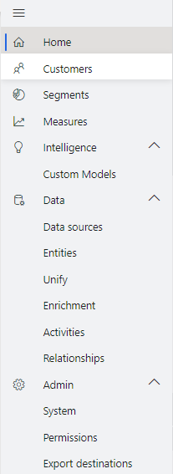**Home:** Home Page

**Customers:** View cards for unified Customer Profiles

**Segments:** Define Segments: Cohorts of Customers based on similar demographic, transactional or behavioural attributes. Use these for targeted marketing, utilising previously siloed data.

**Measures:** Define key Business and Customer KPIs.  
Such as Customer Lifetime Value, Average Purchase Value and Frequency, CSAT and identify high-value customers.

**Intelligence:** Here you can add custom Azure machine learning models to make predictions on your unified customer data.

**Data**: Ingest siloed demographic, transactional of behavioural data and map, match and merge into a Unified Customer Profile. View your entities and define activity types and their relationships to your customers.

**Enrichment:** Go beyond your unified profile and enrich customer profiles with Microsoft Proprietary Data from the Microsoft Graph. Unlock data on affinities for hundreds of brands and dozens of interest-categories. These affinities are extracted for profiles that might be like your customers.

**Admin:** Administer Roles, Permissions and Export Destinations for Customer Segments.

#### Task 2: Ingest Customer Data from Dynamics 365 Customer Engagement

This exercise is to ingest the Customer Data from your Dynamics 365 Customer Engagement

+

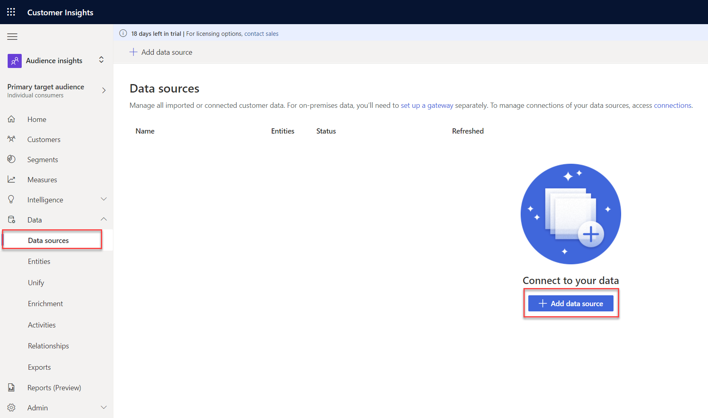

1. Then Next and name the source **D365 Contacts**, then click Next. To import D365 Data, please choose Connect to Microsoft Dataverse managed lake

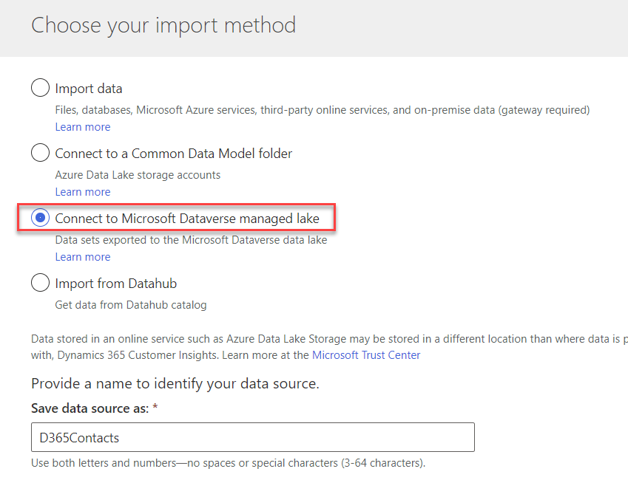

1. Enter the D365 URL you want to connect to and then Sign in, which will prompt you sign in window, you need to enter your credential to sign in. Click next after signed in.

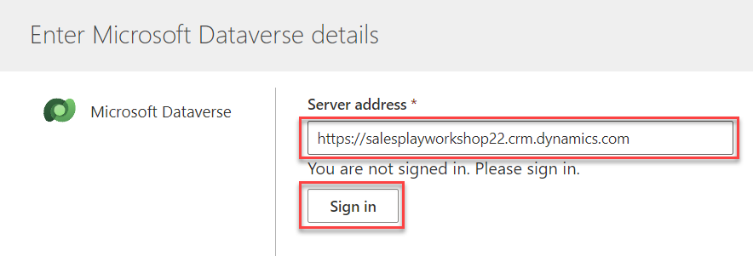

1. In the Entity section, please tick also **Account, Contact, and Product.**  You notice that you can also ingest data from other entities, not just Contact, however please keep the name to D365 Contacts for now.

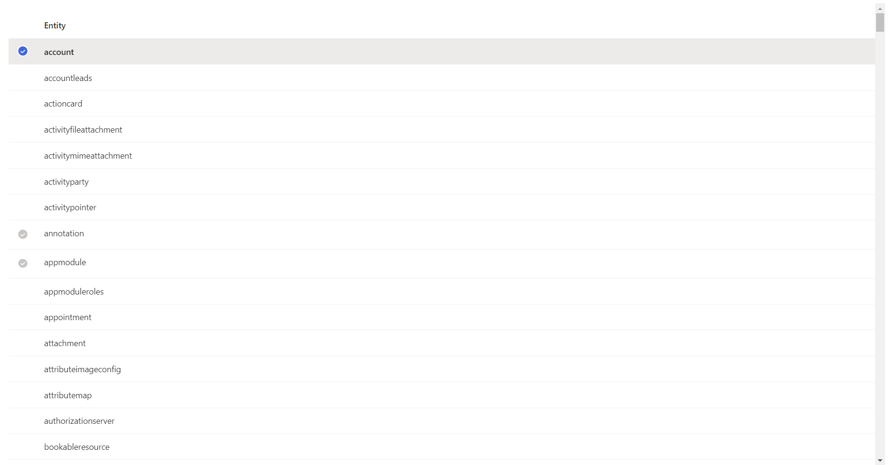

1. Here is the data source you have created. Congratulations!

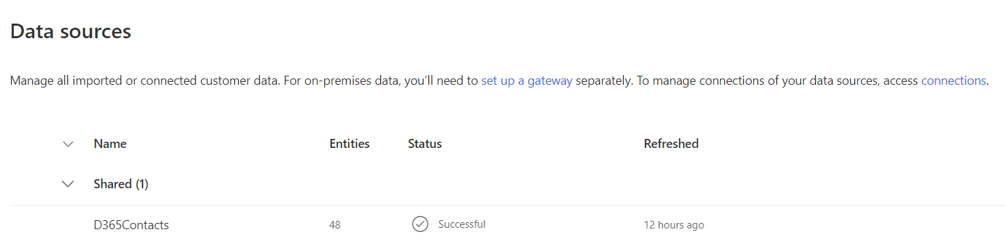

#### Task 3: Ingest Customer Data from Other CRM System

Next task is to connect Customer Insight with other data sources, Customer Insight supports multiple data sources, but in this class that is focusing on the functionality and features, let’s just use CSV files. You will connect to data sources to ingest the data and insert it into our Customer Insight

|  |  |
| --- | --- |
| Contact with Transactions | Extract of contacts who made purchases hence became customers, either from Online or In-Store Purchases  <https://aileenblob.blob.core.windows.net/ciretaildata/ContactswithTransactions.csv> |
| Loyalty Systems | Extract of customers who have signed up Contotech Membership Scheme  <https://aileenblob.blob.core.windows.net/ciretaildata/CustomerLoyalty.csv> |
| Online Purchases | Extract of purchases made via Contotech Website  <https://aileenblob.blob.core.windows.net/ciretaildata/OnlinePurchases.csv> |
| POS Purchases | Extract of in-store purchases  <https://aileenblob.blob.core.windows.net/ciretaildata/POSPurchases.csv> |
| Website Reviews | Extract of reviews from online/websites  <https://aileenblob.blob.core.windows.net/ciretaildata/WebsiteReviews.csv> |

Now, you are going to ingest data from other CRM system that already had the Customer list who has made transaction, this system was built before ContoTech go for Dynamics 365 Customer Engagement, they want to maintain it for now, however Customer Insight as Customer Data Platform will help you to consolidate the data from multiple data source outside Dynamics world.

1. Within Customer Insights, expand **‘Data’** on the left menu and click ‘**Data Sources’**
2. You need to go to Data Sources and then Add Data Source, this time you are connecting to external data which is not Dynamics 365.

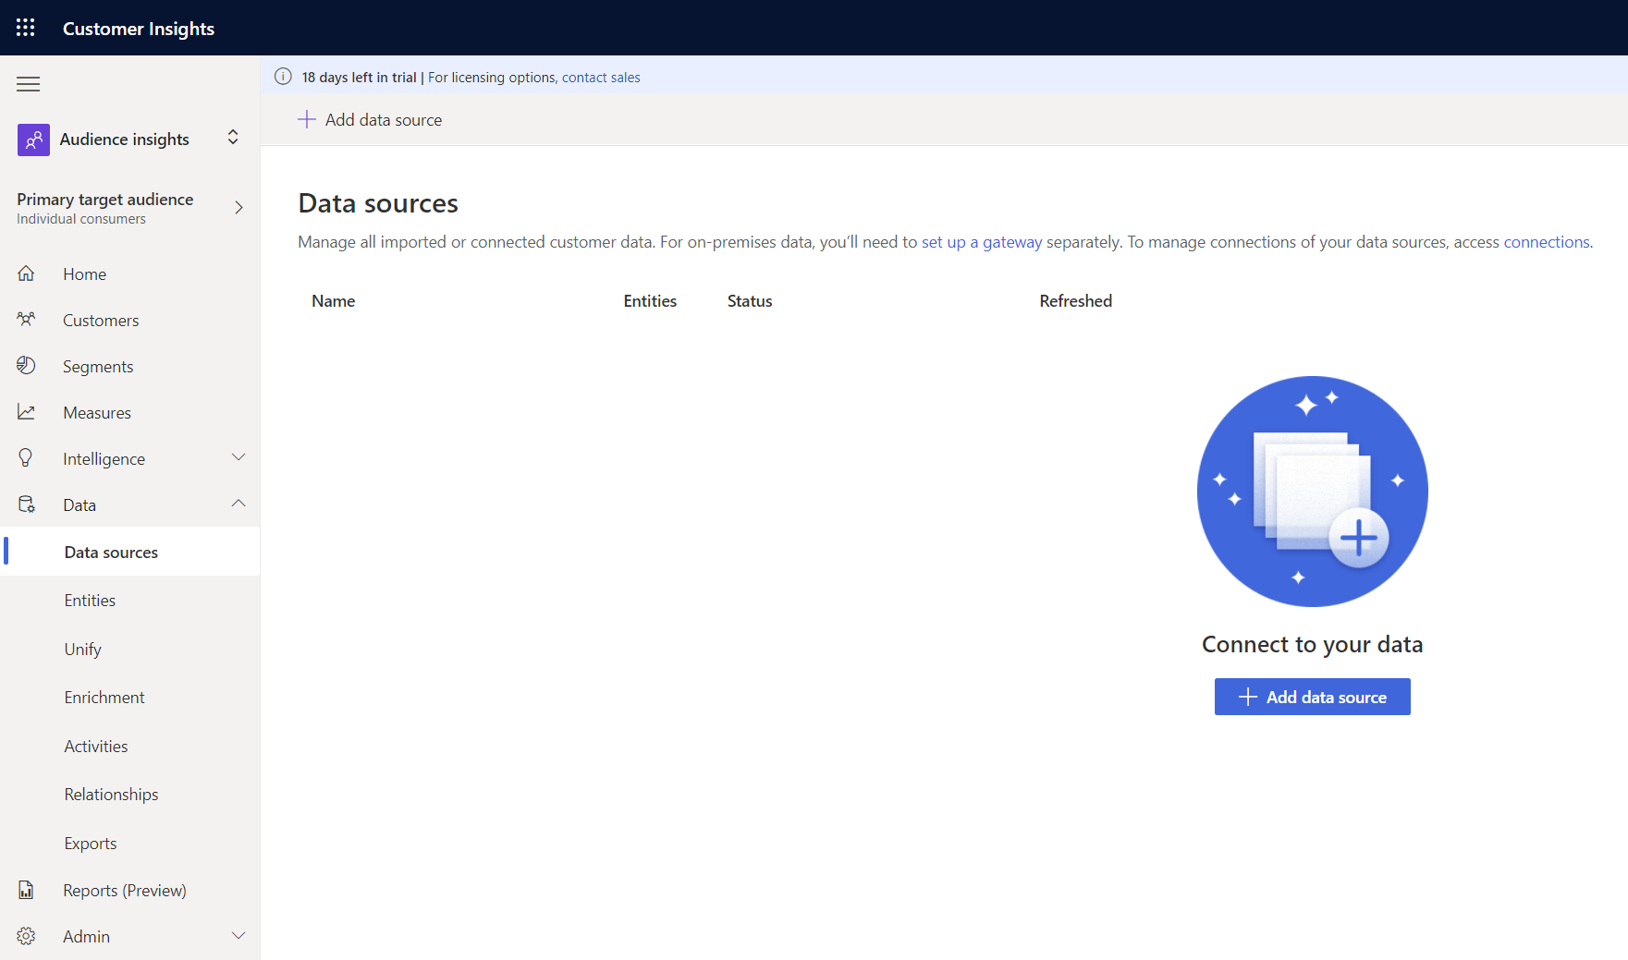

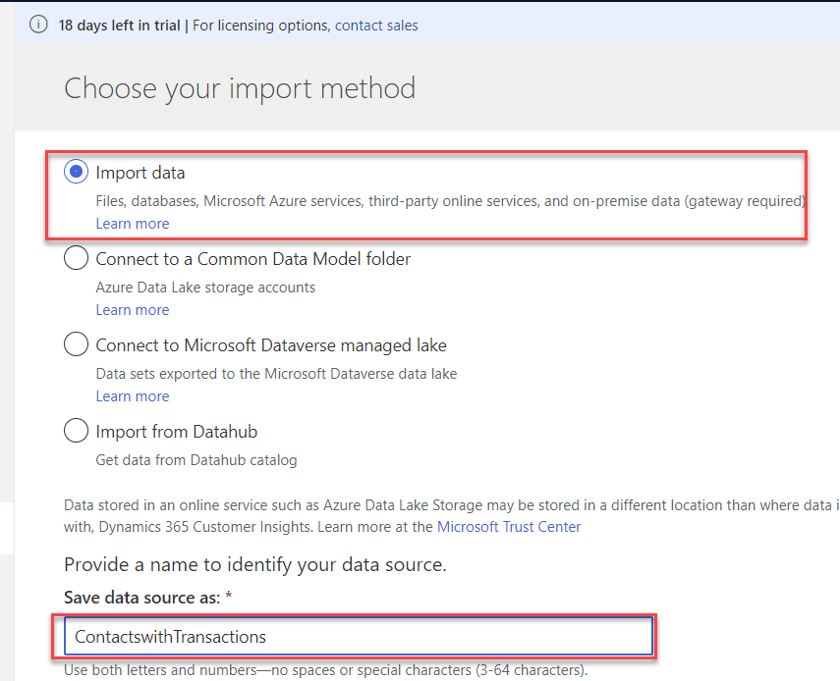

1. You will be presented with a view of data source connectors that Customer Insights is able to ingest. Take note of the connector types available. Select the Text/CSV Connector this time, you will extract and ingest data of customers who have made purchase transactions but may or may not exist in the Dynamics 365 Customer Engagement already, hence you want to consolidate it.

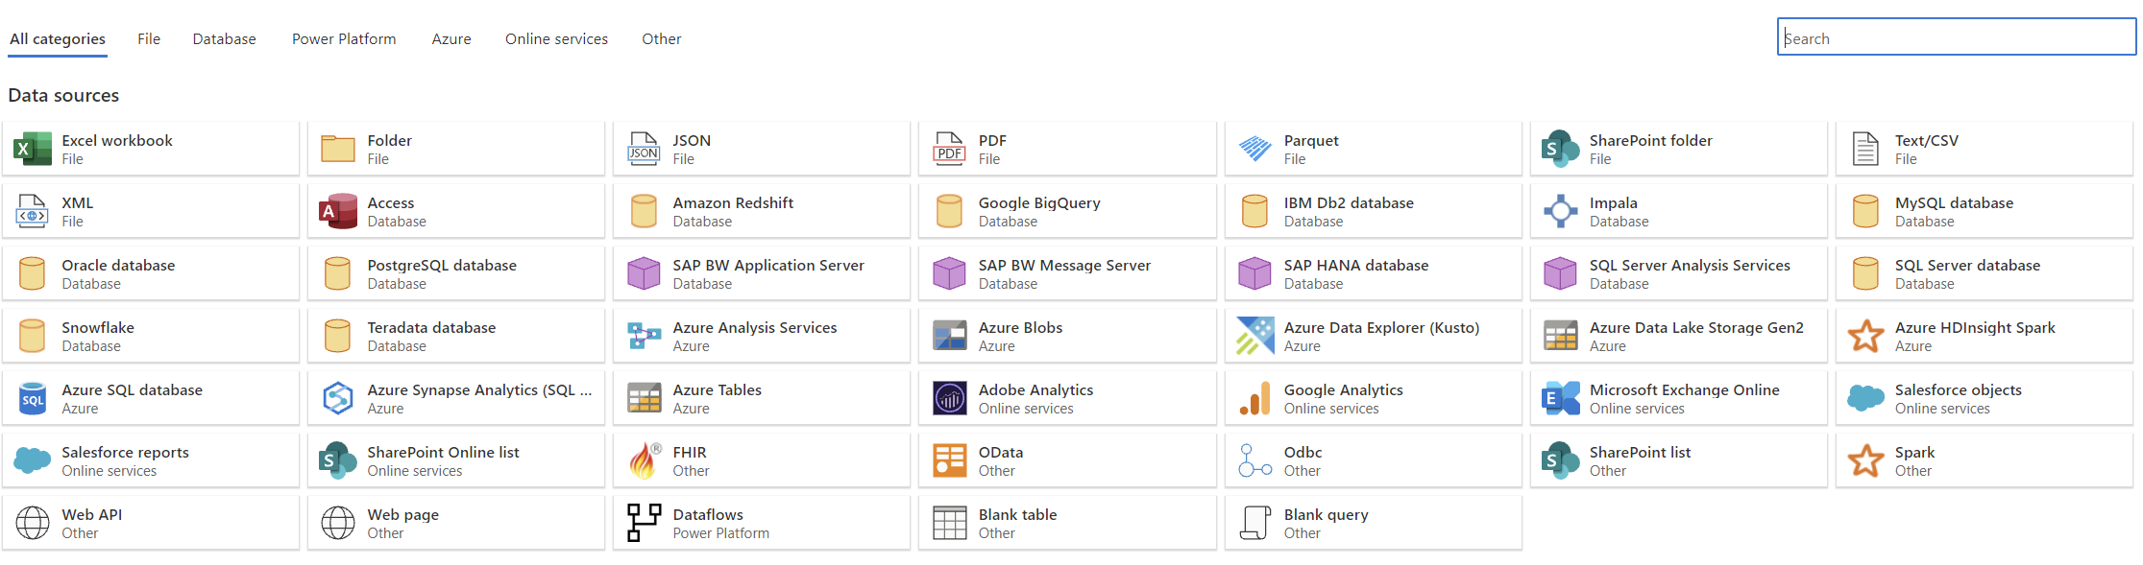

1. Enter the URL for the Azure BLOB for Contacts with Transaction: <https://aileenblob.blob.core.windows.net/ciretaildata/ContactswithTransactions.csv>

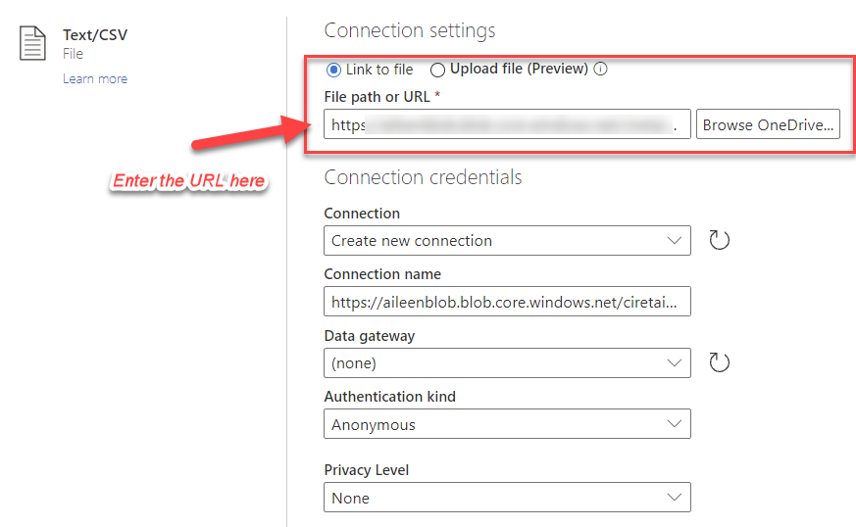

1. You will now see the Preview File Data screen. Here you can change the delimiter, file

origin type or what data is being used for the data type detection. You can simply click

the Transform data button.

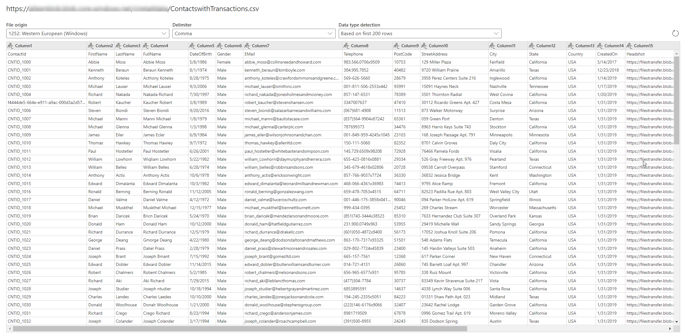

1. You should now see the data from the source tabulated. Here you can configure the

datatypes and formats for the data you ingest.

You will notice that the column heading has appeared in the first row of the data. To

correct this, click Transform and then Use First Row as Headers.

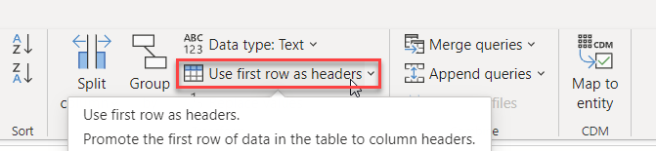

1. Because we have ingested data from a Text/CSV source, all columns have been defaulted to a ‘Text’ Data Type. To successfully ingest and model the data, we can set the datatype for non-text columns.

To change the datatype, click the ABC icon within the column heading.

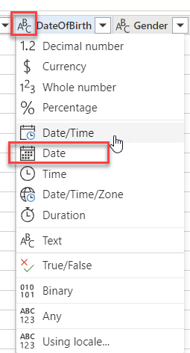

Update the datatype for the columns listed below.

|  |  |
| --- | --- |
| Column Heading | New Data Type |
| DateOfBirth | Date |
| CreatedOn | Date/Time/Zone |

1. In the ‘Name’ field on the right-hand pane, rename your data source from Query to **ContactswithTransactions**

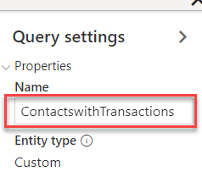

1. You can change the settings to refresh the data automatically or manual.

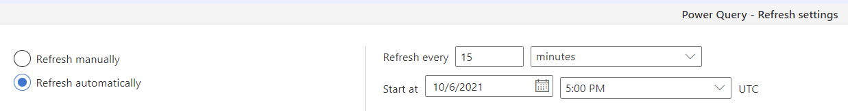

Congratulations! - You have now successfully created your first data source with a dataset from non-Dynamics 365 environment!

#### Task 4: Ingest Customer Data from Customer Loyalty System

1. The same thing as Task 3, you need to go to Data Sources and then Add Data Source, this time you are connecting to another external data which is also not Dynamics 365 Data.

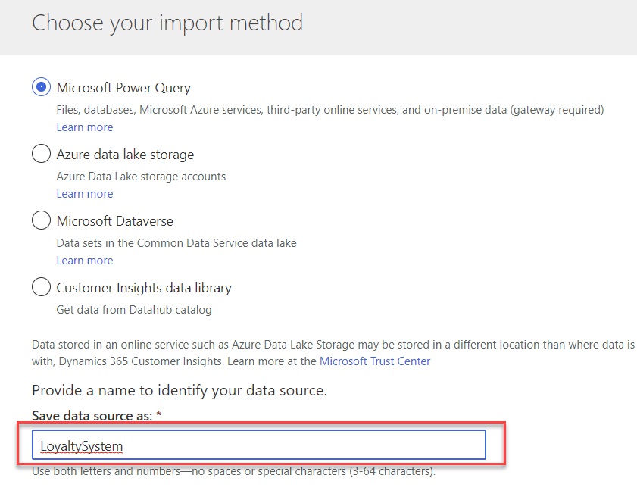

1. You will be presented with a view of data source connectors that Customer Insights is able to ingest. Take note of the connector types available. Select the Text/CSV Connector this time, you will extract and ingest data of customers who have made purchase transactions but may or may not exist in the Dynamics 365 Customer Engagement already, hence you want to consolidate it.



1. Enter the URL for the Azure BLOB for Contacts with Transaction: <https://aileenblob.blob.core.windows.net/ciretaildata/CustomerLoyalty.csv>

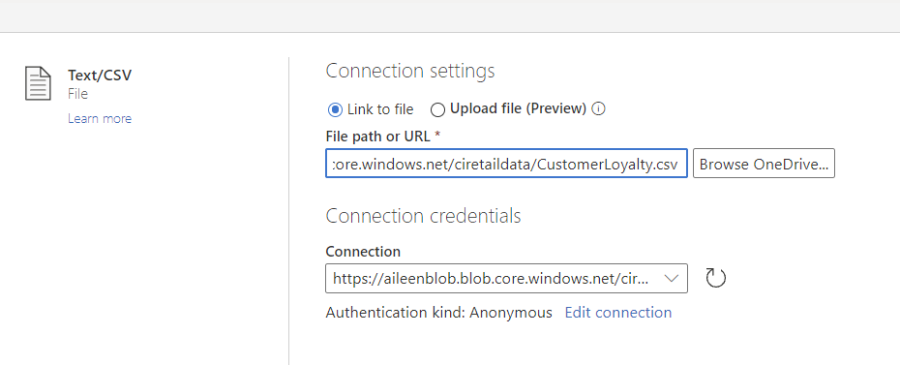

1. You will now see the Preview File Data screen. Here you can change the delimiter, fileorigin type or what data is being used for the data type detection. You can simply click the Transform data button.

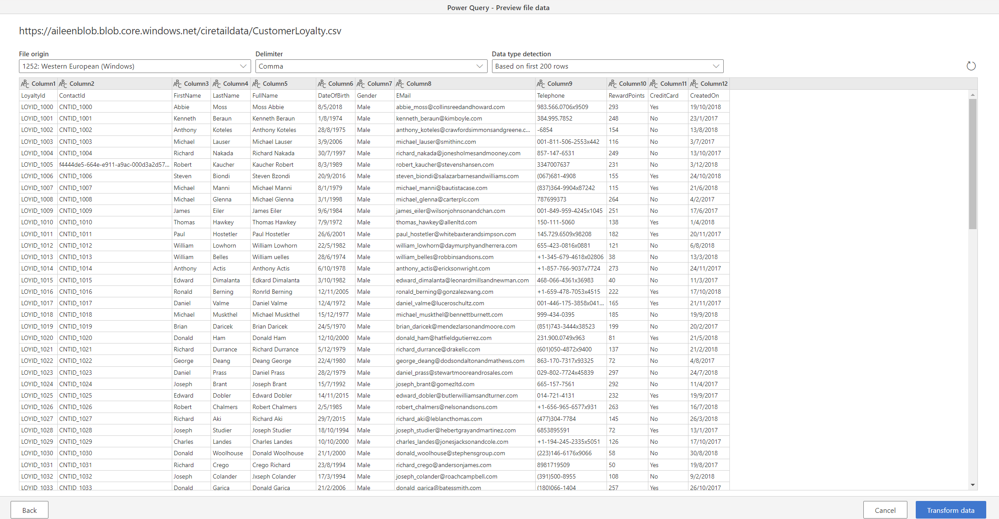

1. You should now see the data from the source tabulated. Here you can configure the datatypes and formats for the data you ingest. You will notice that the column heading has appeared in the first row of the data. To correct this, click Transform and then Use First Row as Headers.



1. Because we have ingested data from a Text/CSV source, all columns have been defaulted to a ‘Text’ Data Type. To successfully ingest and model the data, we can set the datatype for non-text columns.

To change the datatype, click the ABC icon within the column heading.

Update the datatype for the columns listed below.

|  |  |
| --- | --- |
| Column Heading | New Data Type |
| DateOfBirth | Date |
| RewardPoints | Whole Number |
| CreatedOn | Date/Time/Zone |



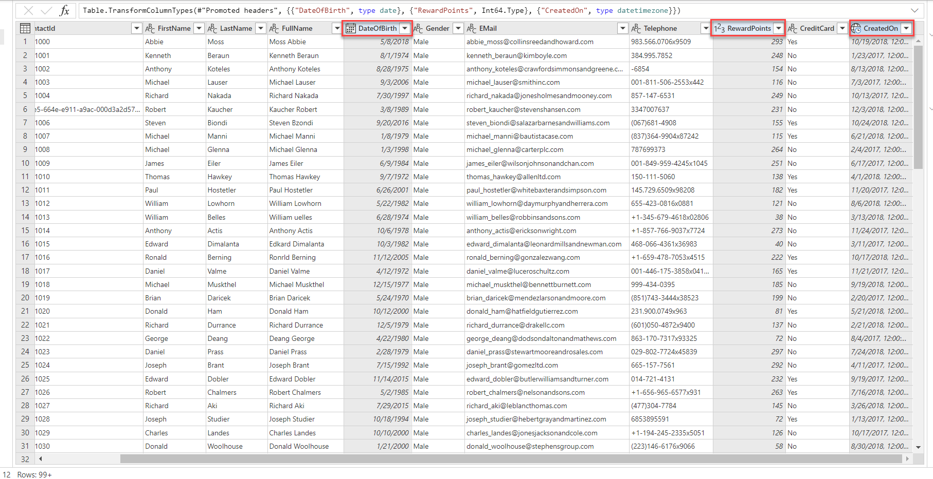

1. In the ‘Name’ field on the right-hand pane, rename your data source from Query to **CustomerLoyalty**

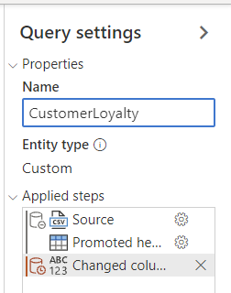

1. You can change the settings to refresh the data automatically or manual.



You can try to look what it is in Refresh Automatically, but for now, just leave it to Manual.

Congratulations! - You have now successfully created your second data source with a dataset from non-Dynamics 365 environment!

#### Task 5: Ingest Customer Data from Online Purchases Platform

1. The same thing as Task 4, you need to go to Data Sources and then Add Data Source, this time you are connecting to another external data which is also not Dynamics 365 Data.

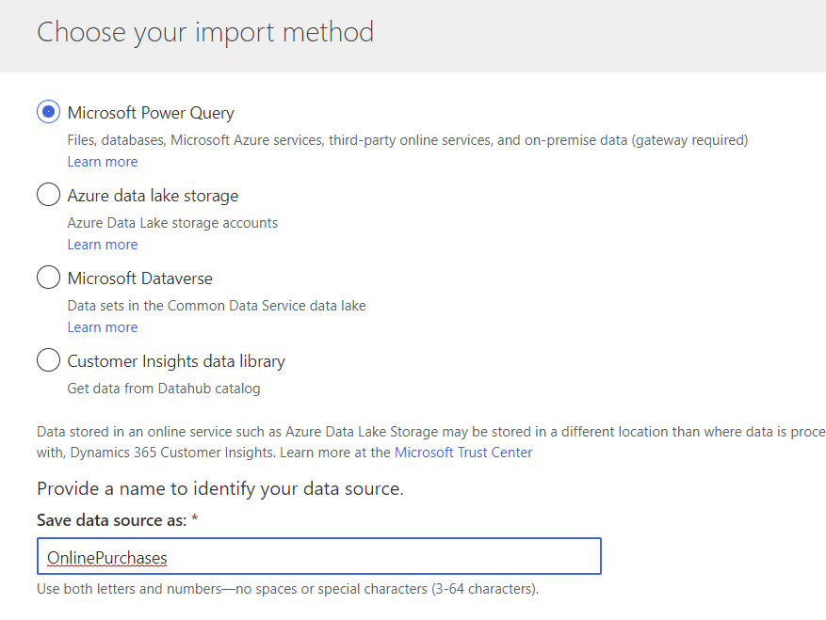

1. You will be presented with a view of data source connectors that Customer Insights is able to ingest. Take note of the connector types available. Select the Text/CSV Connector this time, you will extract and ingest data of customers who have made purchase transactions but may or may not exist in the Dynamics 365 Customer Engagement already, hence you want to consolidate it.



1. Enter the URL for the Azure BLOB for Contacts with Transaction: <https://aileenblob.blob.core.windows.net/ciretaildata/OnlinePurchases.csv>

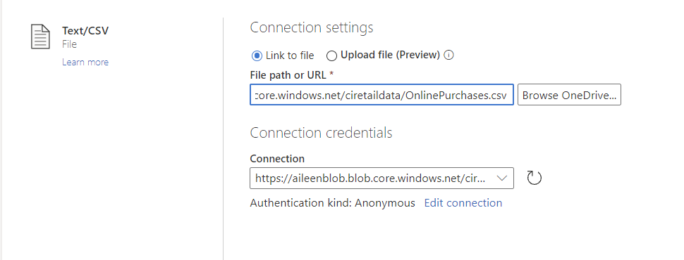

1. You will now see the Preview File Data screen. Here you can change the delimiter, file origin type or what data is being used for the data type detection. You can simply click the Transform data button.

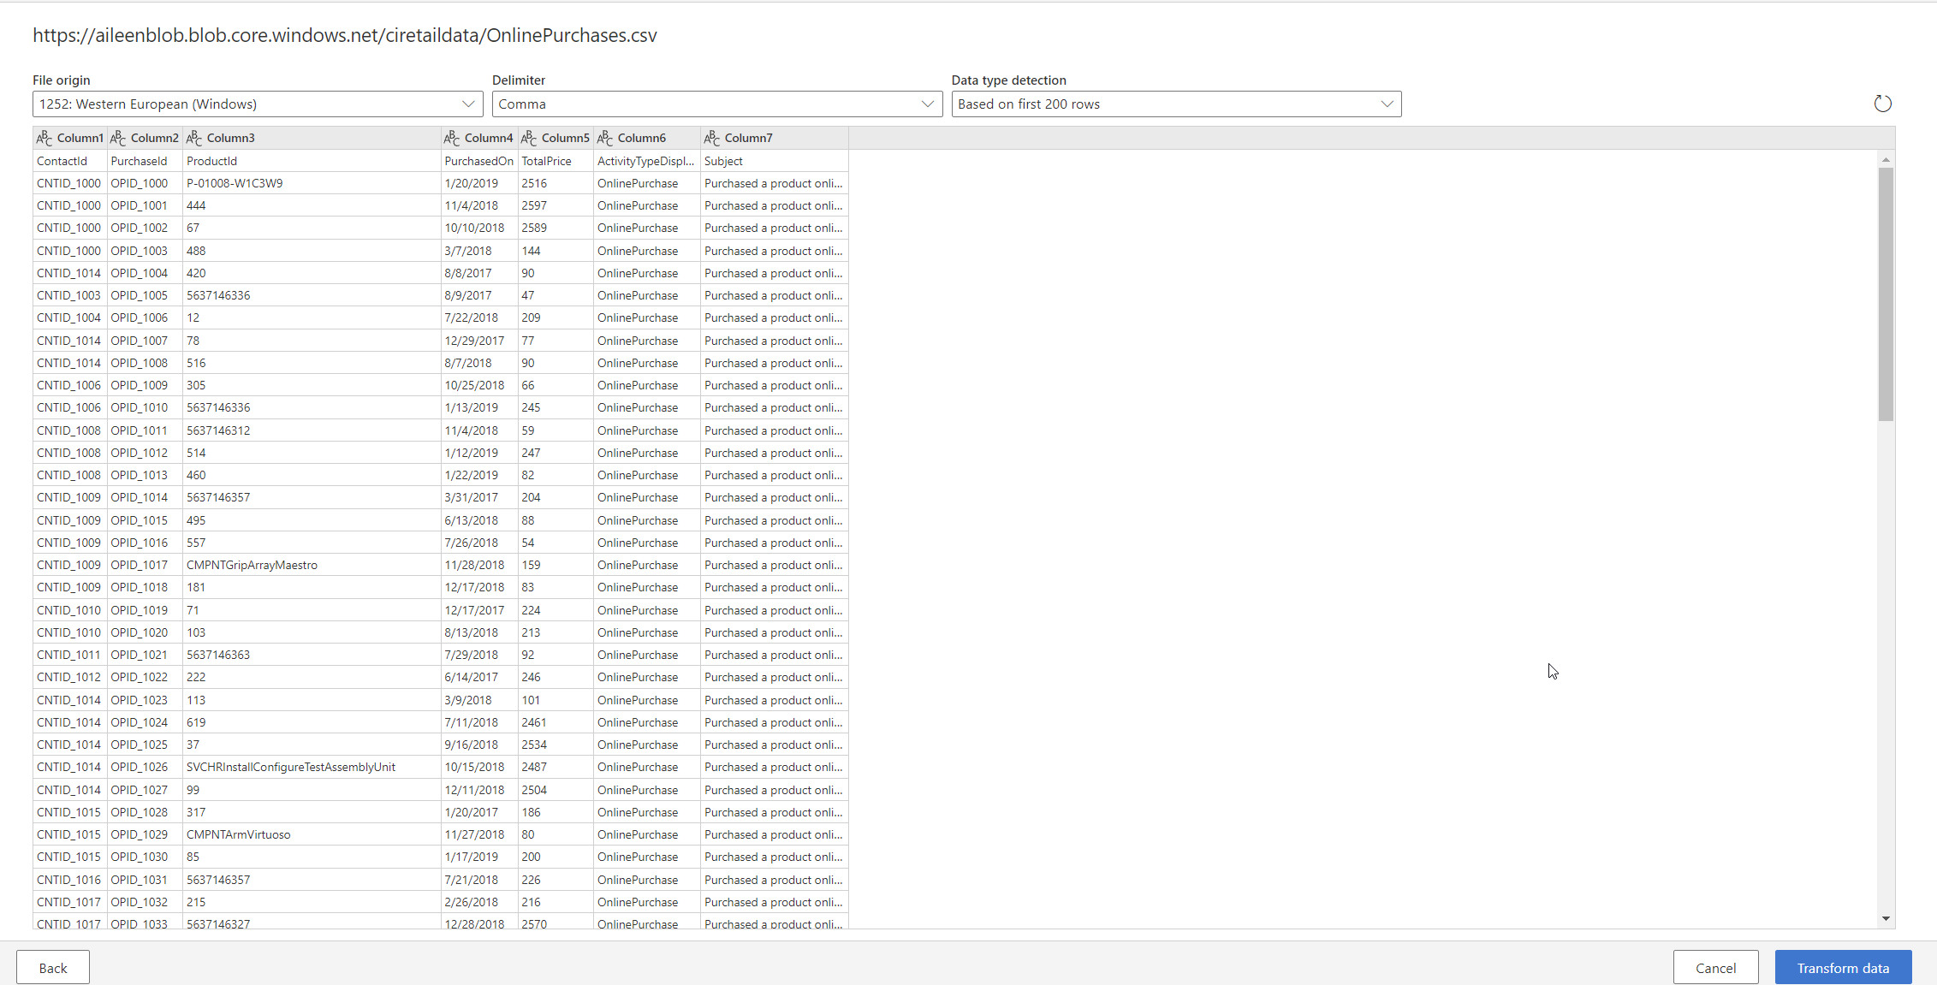

1. You should now see the data from the source tabulated. Here you can configure the datatypes and formats for the data you ingest. You will notice that the column heading has appeared in the first row of the data. To correct this, click Transform and then Use First Row as Headers.



1. Because we have ingested data from a Text/CSV source, all columns have been defaulted to a ‘Text’ Data Type. To successfully ingest and model the data, we can set the datatype for non-text columns.

To change the datatype, click the ABC icon within the column heading.

Update the datatype for the columns listed below.

|  |  |
| --- | --- |
| Column Heading | New Data Type |
| PurchasedOn | Date/Time/Zone |
| TotalPrice | Currency |
| CreatedOn | Date/Time/Zone |

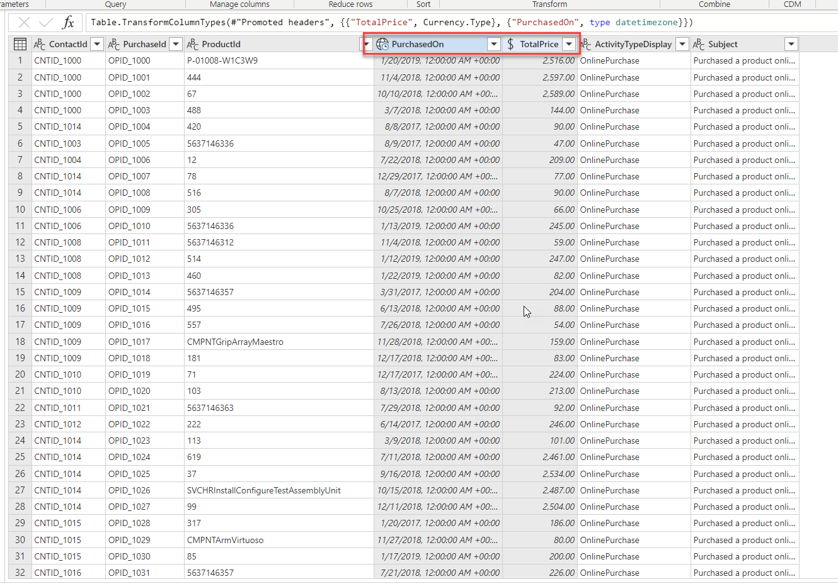

1. In the ‘Name’ field on the right-hand pane, rename your data source from Query to **OnlinePurchases**

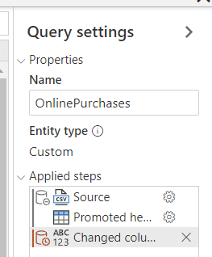

#### Task 6: Ingest Customer Data from Point of Sales Purchases Platform

1. The same thing as Task 5, you need to go to Data Sources and then Add Data Source, this time you are connecting to another external data which is also not Dynamics 365 Data.

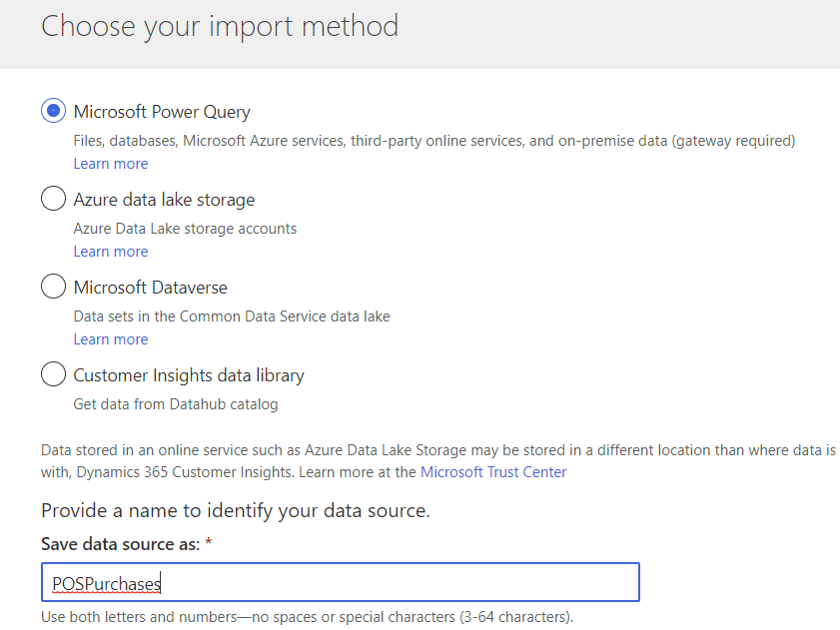

1. You will be presented with a view of data source connectors that Customer Insights is able to ingest. Take note of the connector types available. Select the Text/CSV Connector this time, you will extract and ingest data of customers who have made purchase transactions but may or may not exist in the Dynamics 365 Customer Engagement already, hence you want to consolidate it.



1. Enter the URL for the Azure BLOB for Contacts with Transaction: <https://aileenblob.blob.core.windows.net/ciretaildata/POSPurchases.csv>

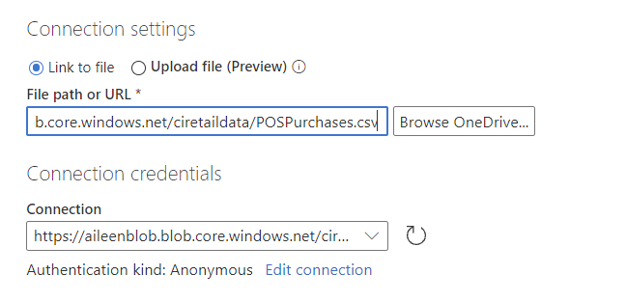

1. You will now see the Preview File Data screen. Here you can change the delimiter, file origin type or what data is being used for the data type detection. You can simply click the Transform data button.

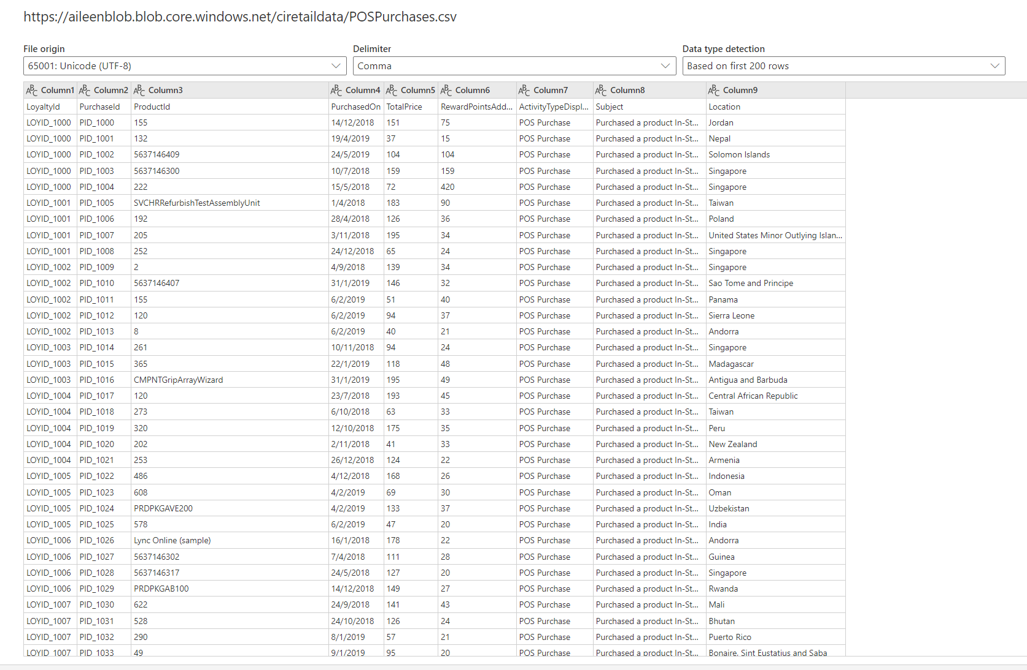

1. You should now see the data from the source tabulated. Here you can configure the datatypes and formats for the data you ingest. You will notice that the column heading has appeared in the first row of the data. To correct this, click Transform and then Use First Row as Headers.



1. Because we have ingested data from a Text/CSV source, all columns have been defaulted to a ‘Text’ Data Type. To successfully ingest and model the data, we can set the datatype for non-text columns.

To change the datatype, click the ABC icon within the column heading.

Update the datatype for the columns listed below.

|  |  |
| --- | --- |
| Column Heading | New Data Type |
| PurchasedOn | Date/Time/Zone |
| TotalPrice | Currency |
| RewardsPointsAdded | Whole Number |

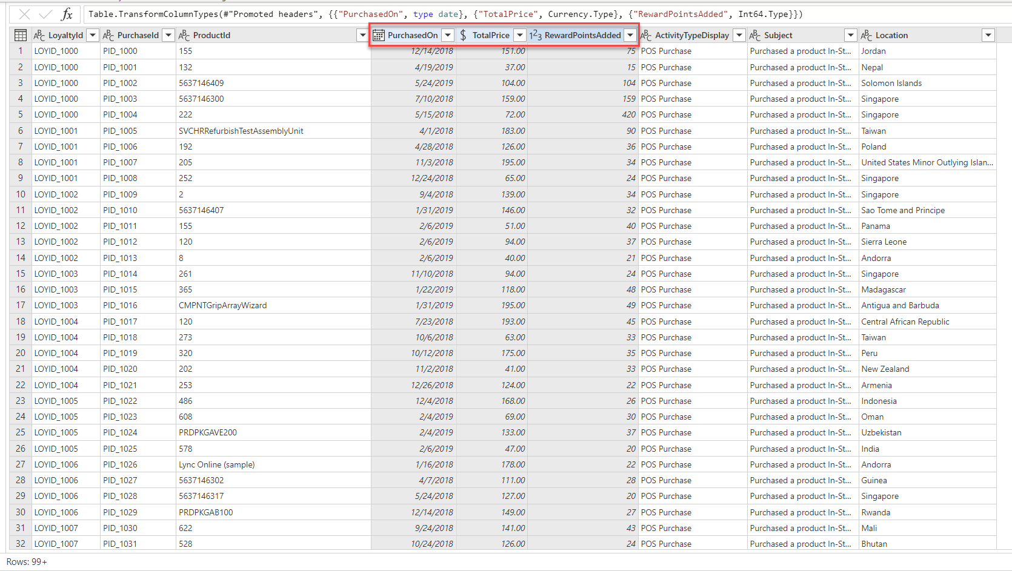

1. In the ‘Name’ field on the right-hand pane, rename your data source from Query to **OnlinePurchases**

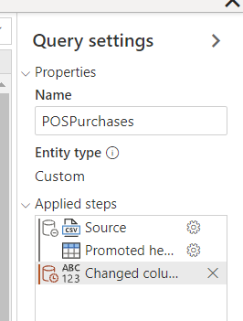

#### Task 7: Ingest Customer Data from Website Reviews

1. The same thing as Task 6, you need to go to Data Sources and then Add Data Source, this time you are connecting to another external data which is also not Dynamics 365 Data.

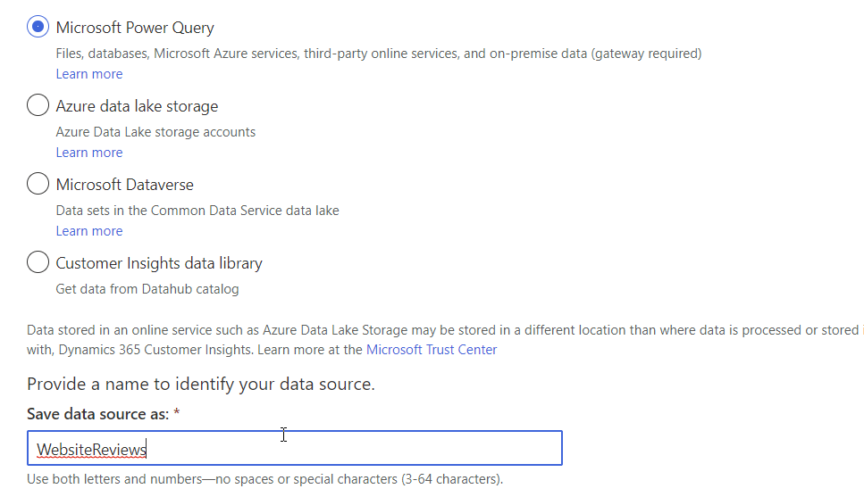

1. You will be presented with a view of data source connectors that Customer Insights is able to ingest. Take note of the connector types available. Select the Text/CSV Connector this time, you will extract and ingest data of customers who have made purchase transactions but may or may not exist in the Dynamics 365 Customer Engagement already, hence you want to consolidate it.



1. Enter the URL for the Azure BLOB for Contacts with Transaction: <https://aileenblob.blob.core.windows.net/ciretaildata/WebsiteReviews.csv>

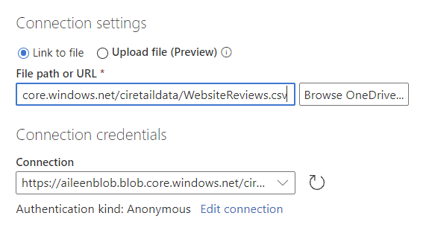

1. You will now see the Preview File Data screen. Here you can change the delimiter, file origin type or what data is being used for the data type detection. You can simply click the Transform data button.

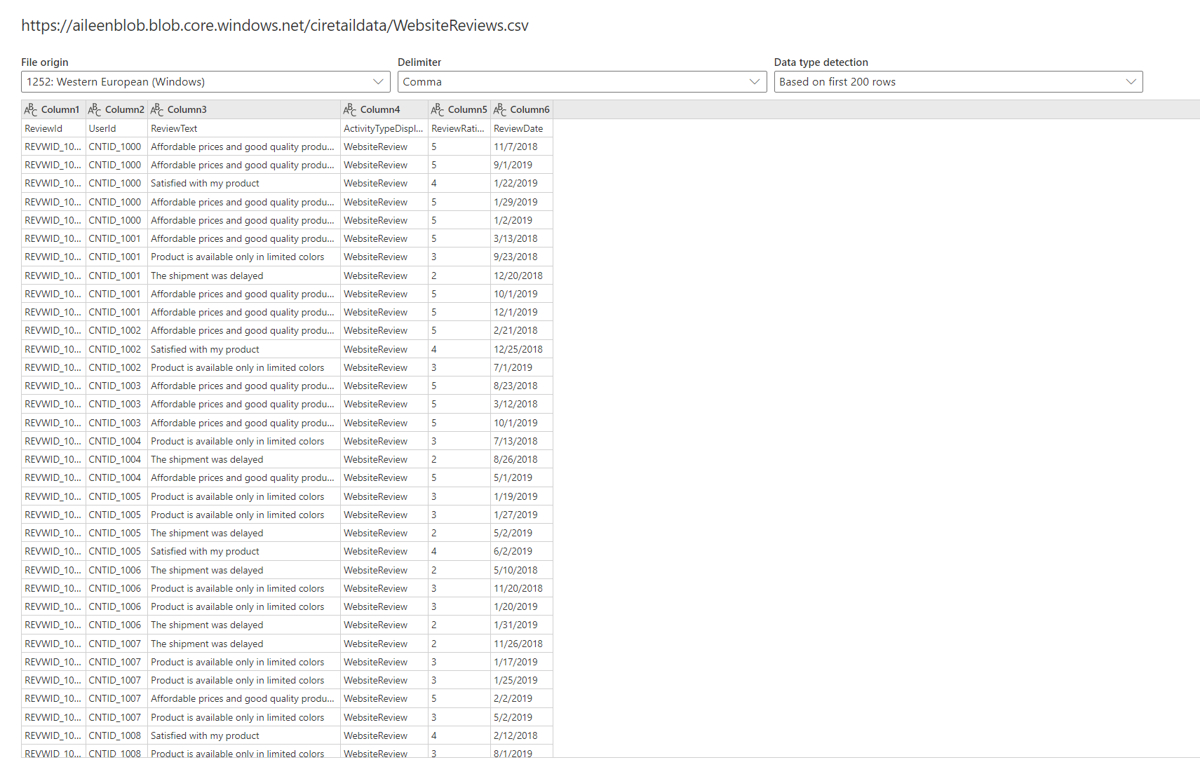

1. You should now see the data from the source tabulated. Here you can configure the datatypes and formats for the data you ingest. You will notice that the column heading has appeared in the first row of the data. To correct this, click Transform and then Use First Row as Headers.



1. Because we have ingested data from a Text/CSV source, all columns have been defaulted to a ‘Text’ Data Type. To successfully ingest and model the data, we can set the datatype for non-text columns.

To change the datatype, click the ABC icon within the column heading.

Update the datatype for the columns listed below.

|  |  |
| --- | --- |
| Column Heading | New Data Type |
| Review Rating | Whole Number |
| ReviewDate | Date/Time/Zone |

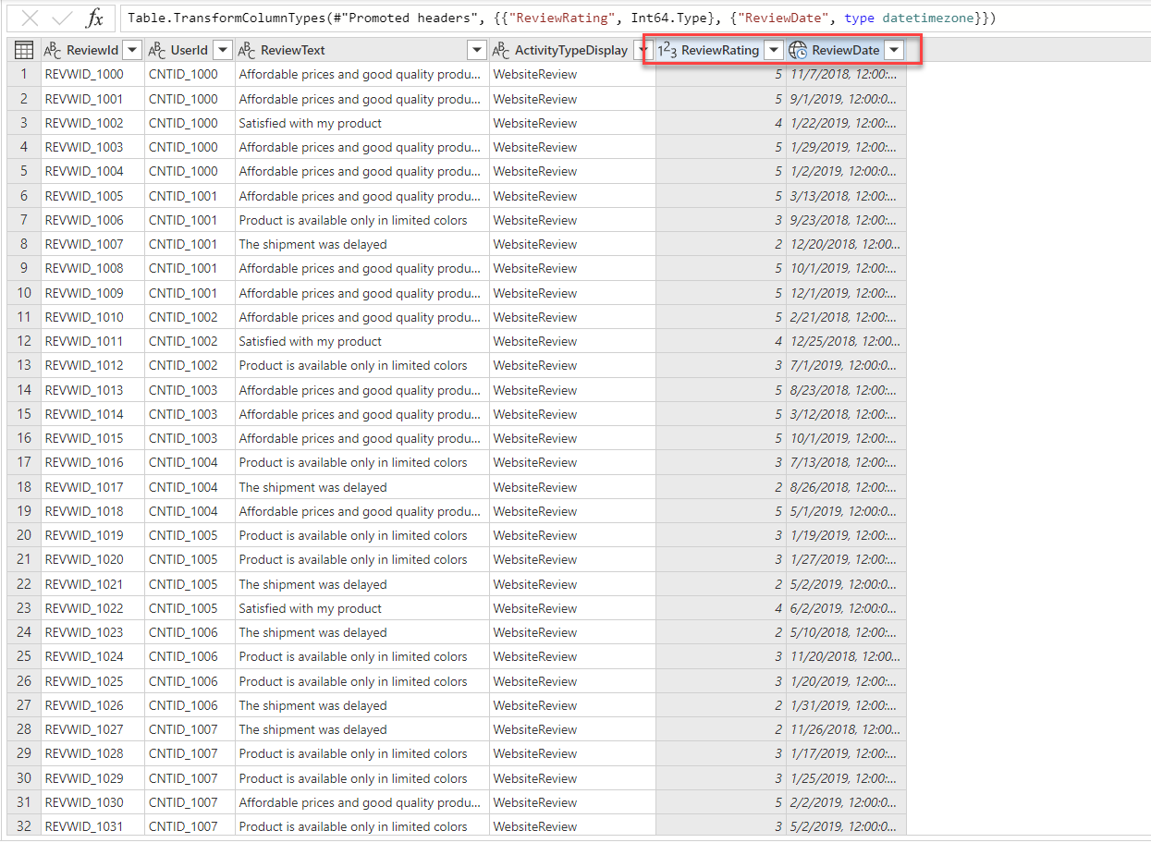

1. In the ‘Name’ field on the right-hand pane, rename your data source from Query to **WebsiteReviews**

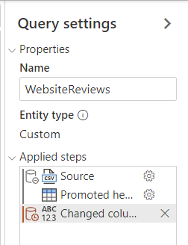

Now that all sources are ingested, you should end-up with one shared data source from your Dynamics 365 and other five data sources as below.

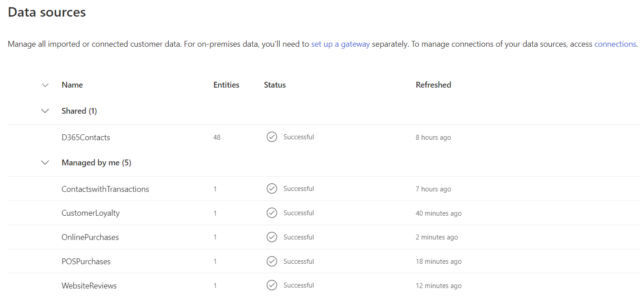

When you view each data source you should see the corresponding query names in the window on the right-hand side*.*

*If you named your queries differently then you will need to make adjustments as you go through the content as this content assumes the naming providing in the steps above.*

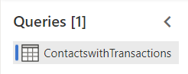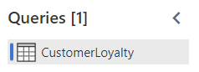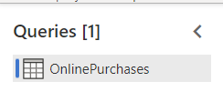

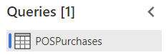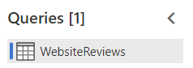

## Exercise 2: Data Unification

Having ingested the raw data from your data sources into ‘entities’ you will now begin the **Map 🡪 Match 🡪 Merge** process to create a single **Unified Customer Profile** by merging data from each customer profile source.

To do this you will first map your ingested entities against a standard model and select the Primary Key for each of your profiled entities. Following the completion of this you will then create your ‘Match Rule’ that will be used to match ContactswithTransaction (Contacts you extracts from other CRM System) customers with Loyalty Customers. Also, we want to consolidate the customer data from Dynamics 365 as well.

Finally, running the ‘Merge’ process will create a single set of unique ‘Customers’ having matched profiles from other CRM System and Loyalty customer data using your match rules.

Your objective is to find out how many unique customer profiles ContoTech has across Dynamics 365, other CRM System, and Loyalty data.

#### Task 1 – Map contacts from ContactswithTransaction and CustomerLoyalty System to common data types

1. Map contacts from Contacts and Loyalty data to common data types.

In the left menu click **Unify 🡪 Map 🡪 Select Entities**

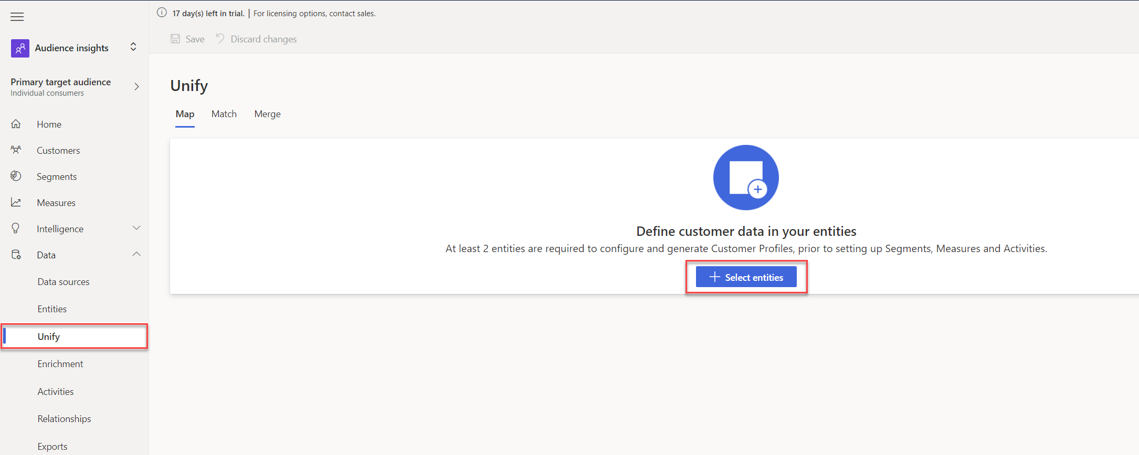

Select the entities that represent the customer profile – **Customer Loyalty**, **ContactswithTransactions**, and **contact** then click **Apply.**

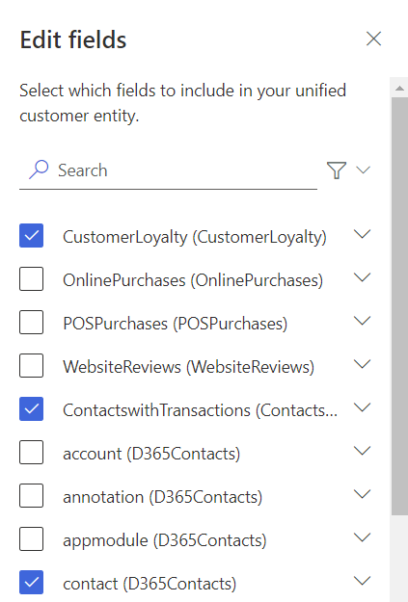

1. You will now be presented with the mappings of your source entity against standard model types. You can review the types in the table.

You must choose a ‘Primary Key’ for each entity you have ingested. The primary key must be a unique reference. For **contact from D365 Contacts** select **contactId** as the Primary Key.

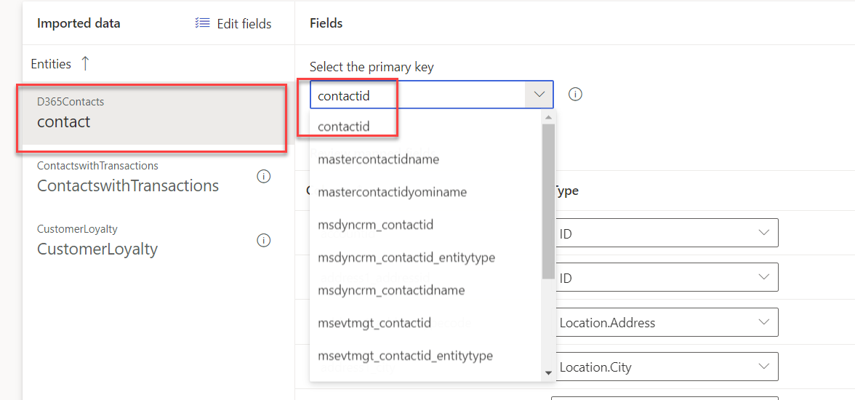

1. For **ContactswithTransactions**, set the **ContactId** as the primary key.

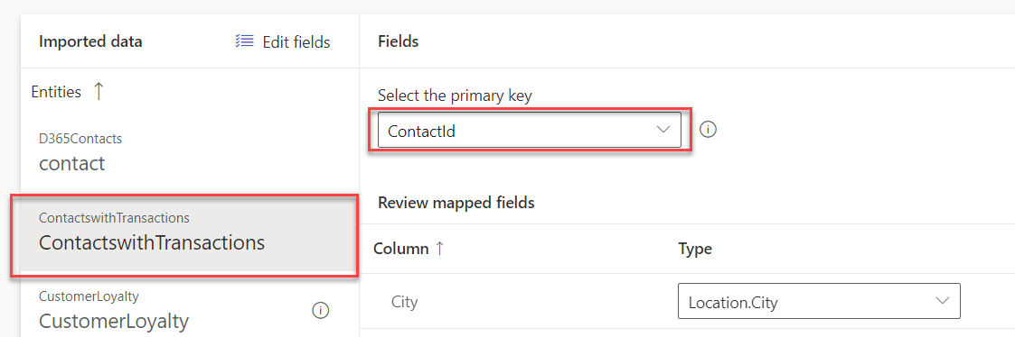

1. For **CustomerLoyalty**, set the **LoyaltyId** as the primary key.

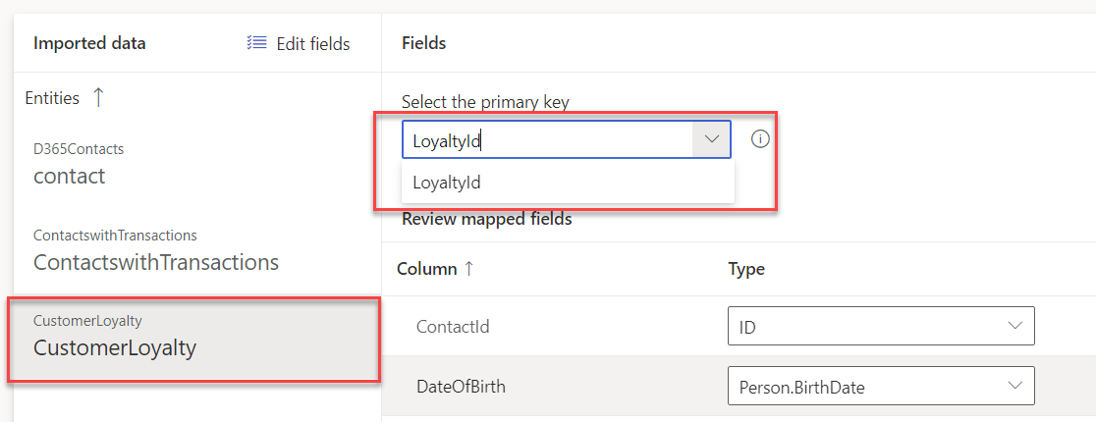

You also notice that the Intelligent Mapping is auto enabled

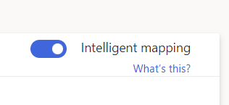

1. Then click **Save** in the top left-hand corner.

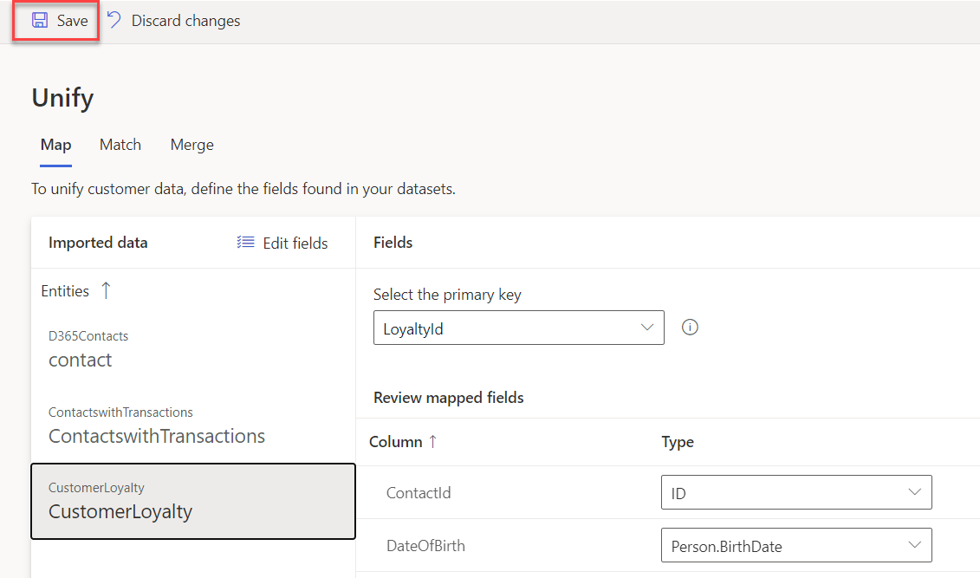

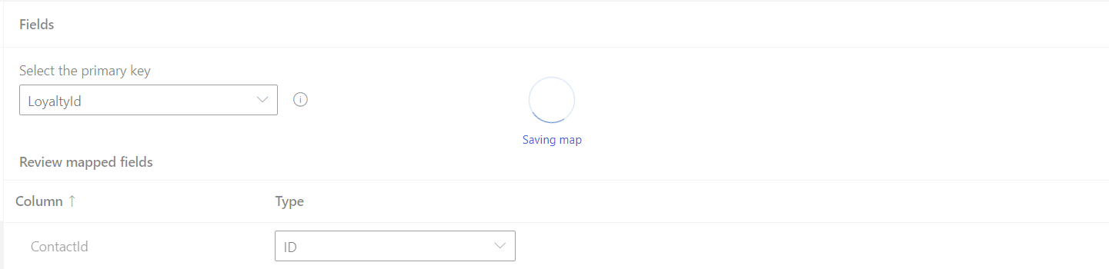

1. Click **Match**

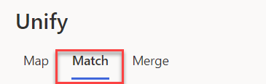

#### Task 2 – Specify Match Order

For the next stage, we must select the order in which to merge the profiles. You will be able to merge attributes to ensure that the unified profiles are complete as well as the priority of which sources to use for those attributes.

1. If you haven’t already, Click **Match** in the top menu on the page.



1. You should select the most complete or accurate profile source as the Primary.

Click **Match 🡪 Set Order**

1. In this case, since Dynamics 365 is pretty new system for ContoTech, we will use old CRM system as primary, then their loyalty, after that it is the D365 Contacts itself, choose to include all records
2. In the **Entity** **2** drop-down list select **loyCustomers : LoyaltyScheme** and choose to include all records.

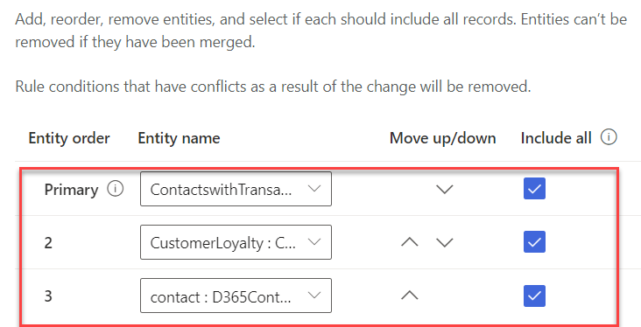

1. Click **Done**

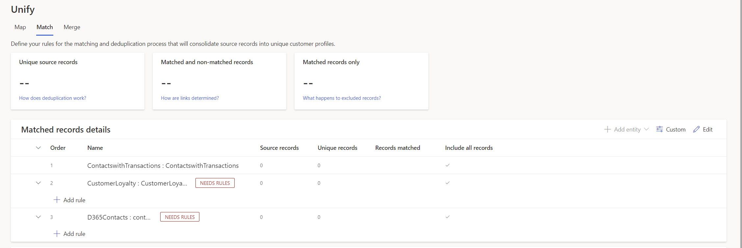

#### Task 3 – Create a Match Rule

In this step, you will create a simple rule used to match records together. Rules can consist of single (e.g. based on ID) or multiple conditions (e.g. Full Name, Postcode, Date of Birth).  
For this exercise you will create a match rule based on Full Name, Postcode and Email.

For further details on Match Rules, please see [Customer Insights](https://docs.microsoft.com/en-us/dynamics365/ai/customer-insights/pm-match" \l "step-two-define-rules-for-your-first-match-pair)) [documentation](https://docs.microsoft.com/en-us/dynamics365/ai/customer-insights/pm-match" \l "step-two-define-rules-for-your-first-match-pair)).

1. Click **+** **Add Rule**

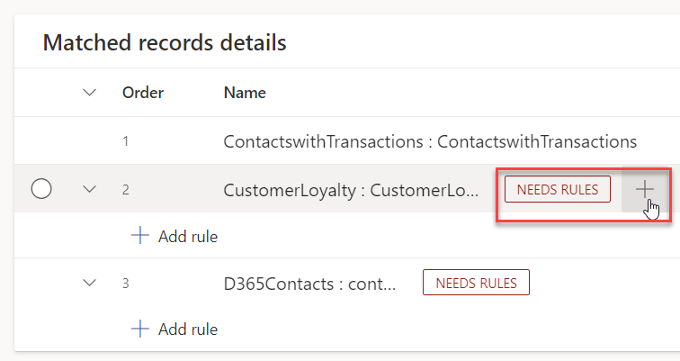

1. Add first condition as below

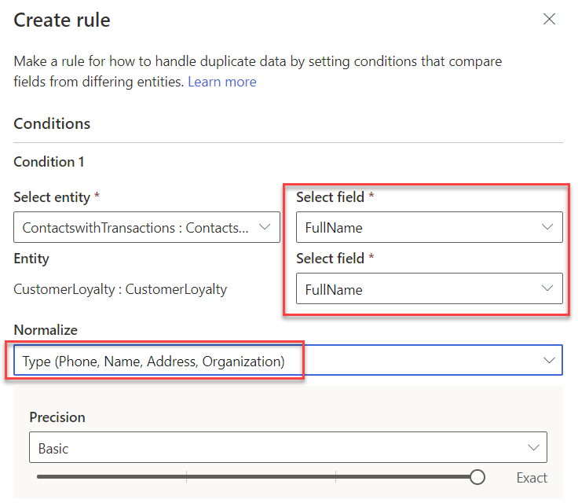

Click the **Normalize** drop down and select **Type (Phone, Name, Address, …)**. This will normalize the values within the name Full Name field.

Set Precision Level to **Basic** and Precision to **High**

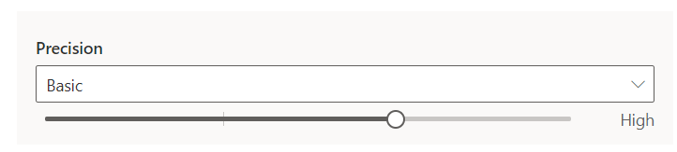

1. Add your second condition as below
2. Enter the name **FullName, Email** for the new rule.
3. Add your first condition using FullName  
   **-** entity eCommerceContacts select **FullName** in Field drop-down  
   **-** For entity loyCustomers select **FullName** in Field drop-down  
   **-** Set Precision Level to **Basic** and Precision to **High  
   -** Click the **Normalize** drop down and select **Type (Phone, Name, Address, …)**. This will normalize the values within the name Full Name field.

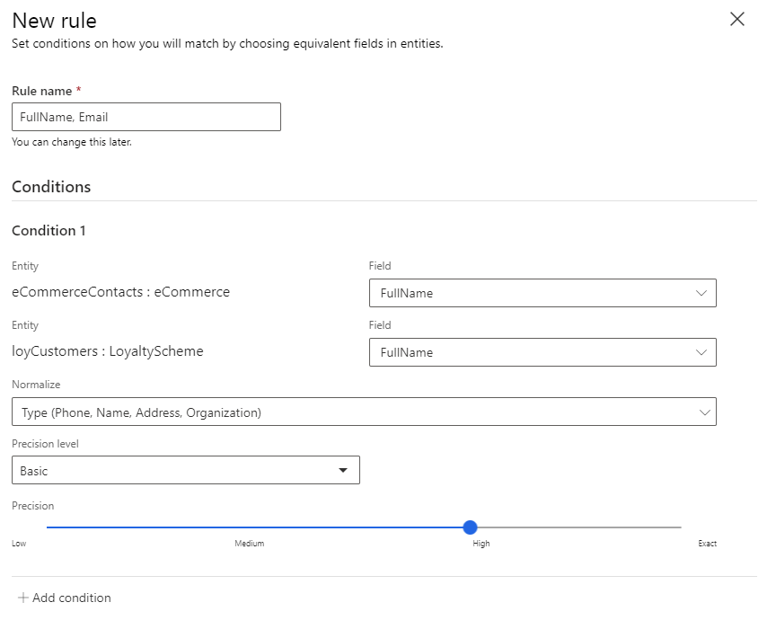

1. Add a second condition for email address by clicking **Add Condition**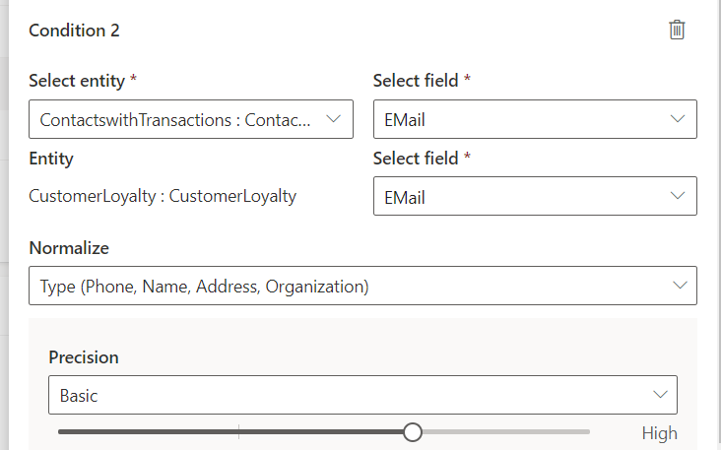

**Notes on Precision -** Exact, on the left-side of the scale, will match records where your condition has an exact match. Select one of the other levels to match records that are not 100% identical. **High** fits cases where precision is more important than reach, such as a financial service to a specific customer. **Low** fits cases where the opposite is true, such as a marketing campaign. The Medium level serves as a middle-ground option.

1. Scroll down and name the rule

Enter the name **FullName, Email** for the new rule.

Your match rule should now appear like the below. Click **Done.**

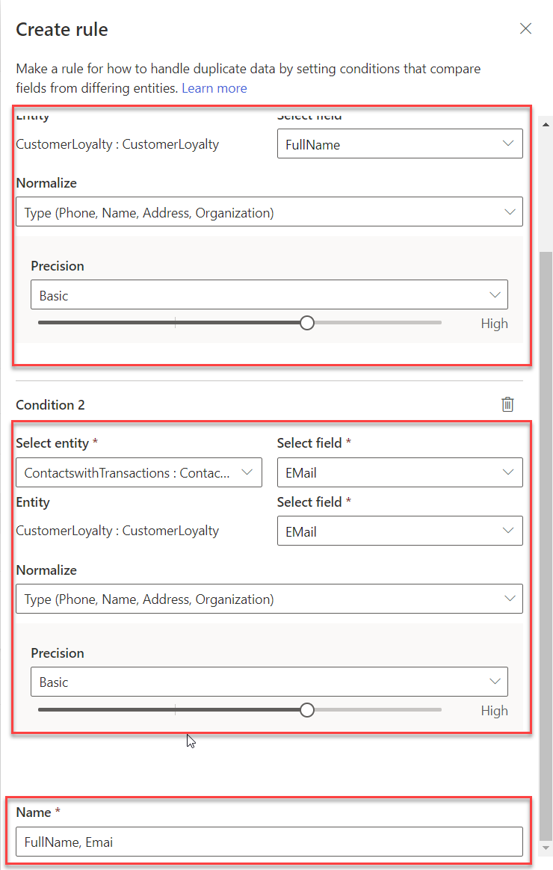

1. Create another rule to match with D365 Contacts

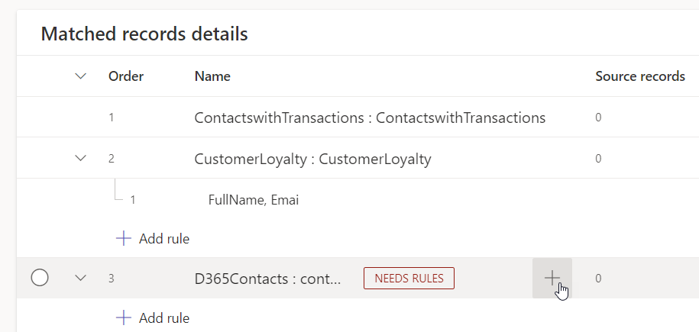

1. Add first condition as below.

Now, you want to match **ContactswithTransactions** that you get from other CRM System with our Dynamics 365 Contacts by matching it with fullname and email

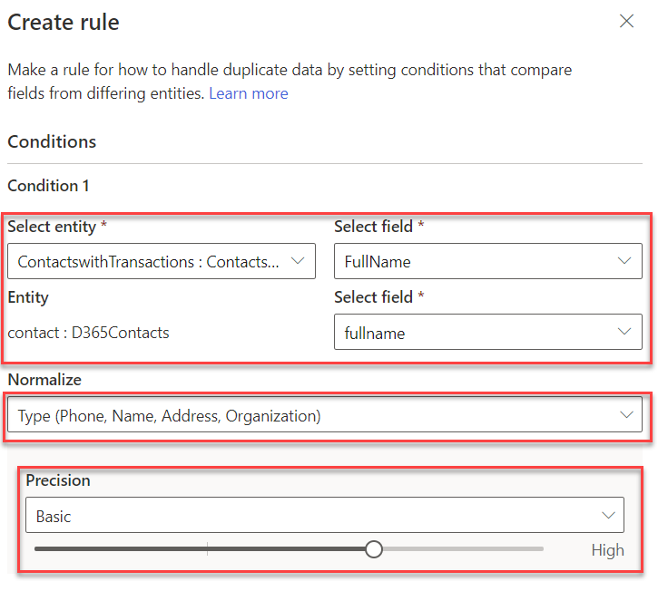

1. Then, with the same entity, add another condition using email to match

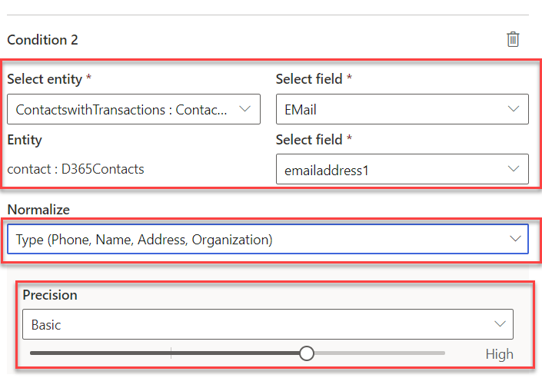

1. Name your rule and click **Done.**

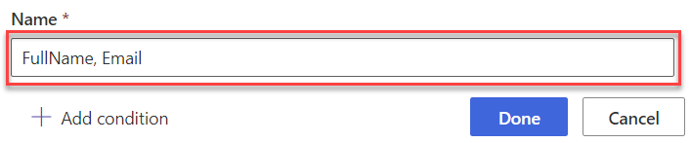

1. In the top left-hand corner click **Save** and then **Run.**

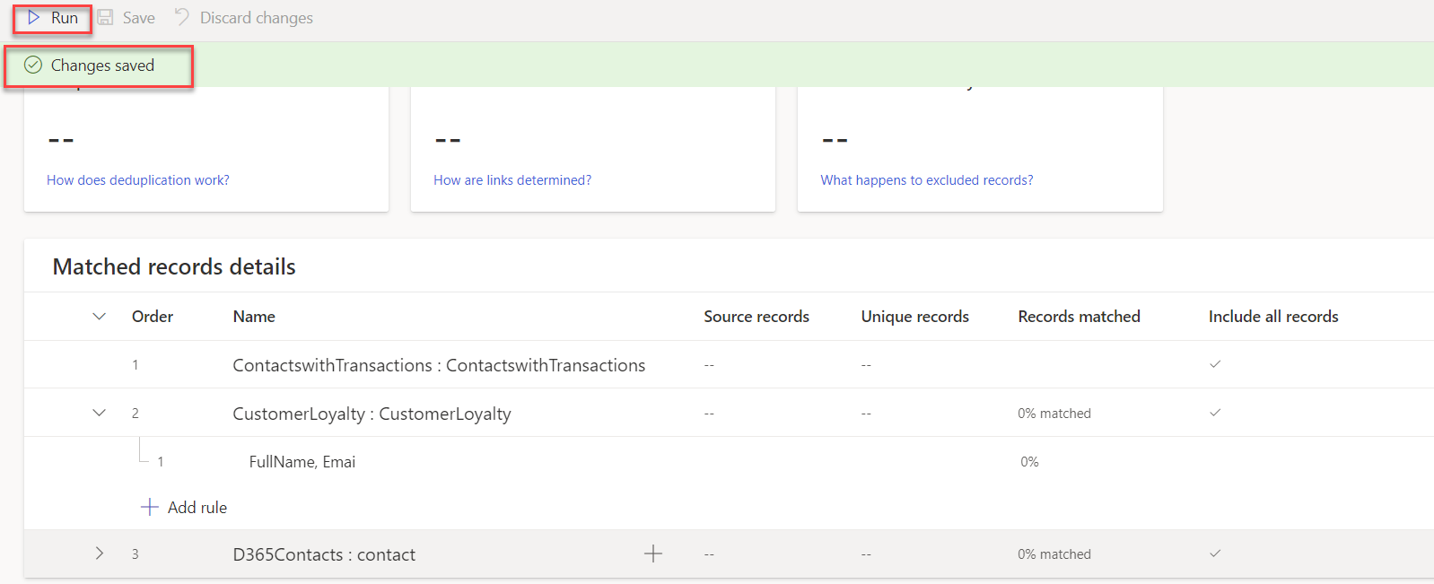

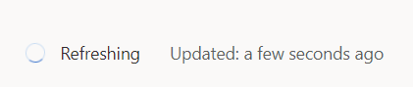

Customer Insights is now matching customer data from your three sources of customer information – ContactswithTransactions, CustomerLoyalty, and D365Contacts customers to identify how many unique customer profiles you would have based on your rules

**How Many Unique Customers do you have when combining your two datasets?**

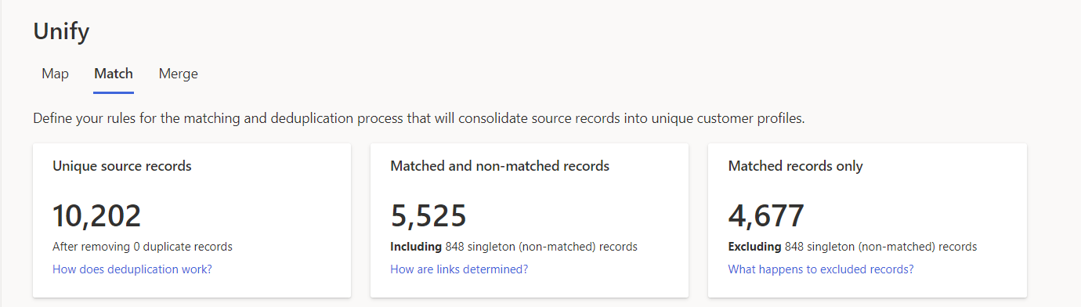

#### Task 4 – Precision

In Task 3, we used **High Precision** in the match-rule against Full Name. In this task, you will adjust the precision level, to create a higher number of matches, by including matches of a lower confidence (resulting in lower number of unique profiles).

**Notes on Precision -** Exact, on the right-side of the scale, will match records where your condition has an exact match. Select one of the other levels to match records that are not 100% identical. **High** fits cases where precision is more important than reach, such as a financial service to a specific customer. **Low** fits cases where the opposite is true, such as a marketing campaign. The Medium level serves as a middle-ground option.

1. Expand your rule and click the to edit the ‘Match’ Rule.
2. Move the Precision slides for your **FullName** match from **High** to **Low.** Then click **Done.**

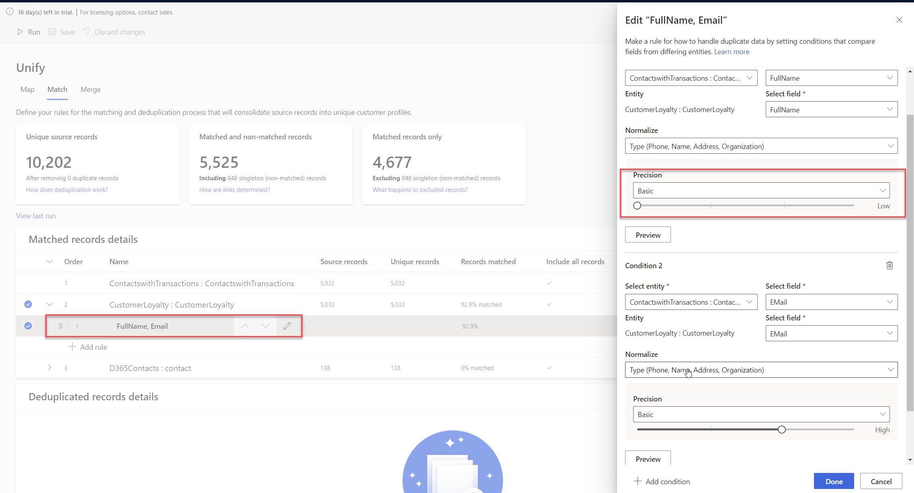

1. Click **Save** and then **Run.**
2. Once the match process has completed, click the 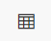 icon, to view a **Match Preview** of the match results and the **Confidence Score** as to how certain Customer Insights is that they are a match based on the rules you have defined. – You will notice that some profiles have been created with a low confidence of matching.

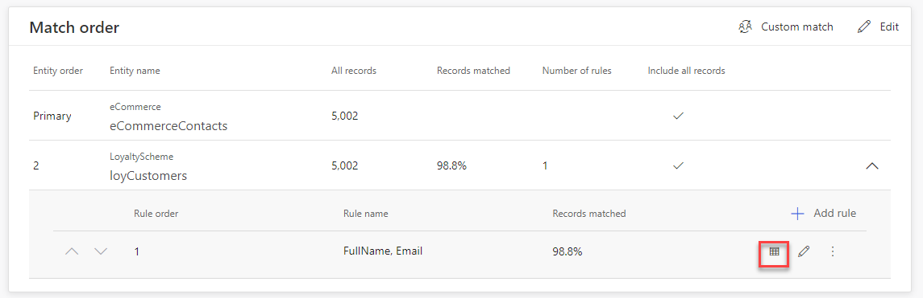

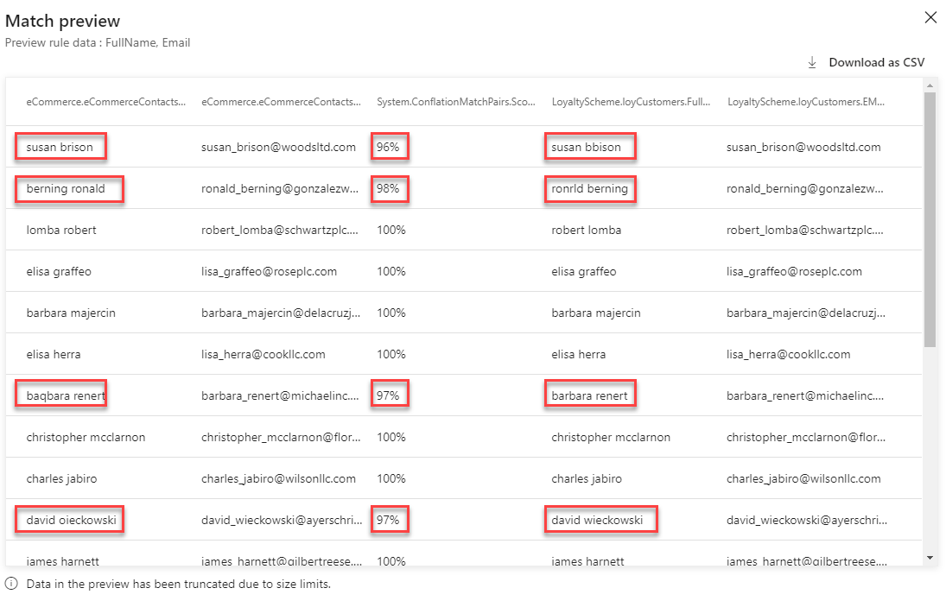

1. Close the preview and click the  to edit the match rule. Click the **Preview** button below the Email rule.

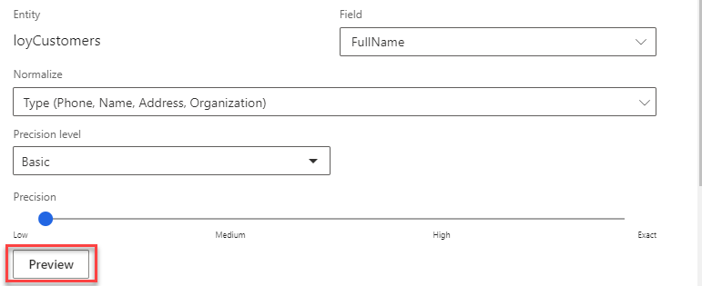

1. Here you can preview the number of Unmatched and Matched for your full name criteria. This screenshot shows that there were 57 Unmatched and 4945 Matched. ***Note:*** *Your number may be slightly different if the underlying data sources have changed since the docs were create or the matching algorithm has changed.*  
   Click **Preview Data** under **Unmatched** or **Matched** to preview the matches. Notice how High Confidence uses exact spelling but can match even if the name format (First Name, Last Name / Last Name, First Name) is different. With Low confidence, notice how matches are made even when names are not spelled identically.

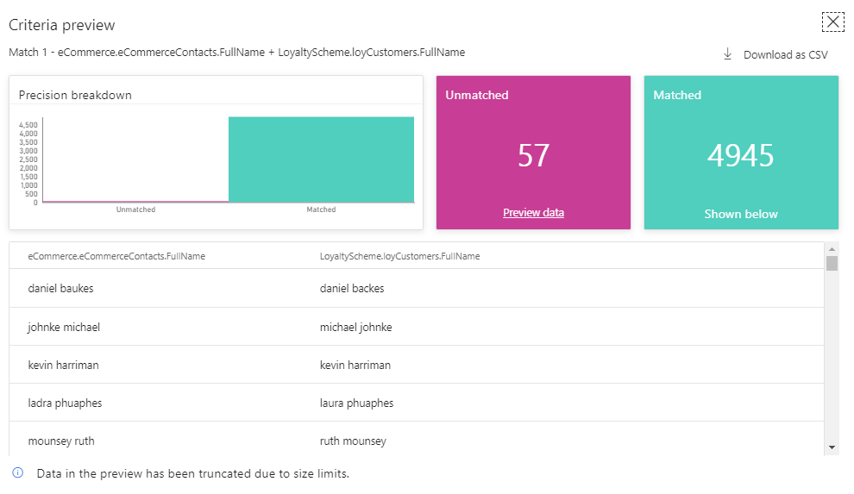

1. Close the Criteria Preview page. And click **Cancel**.

**How many Unique Customer Profiles do you have now?**

#### Task 5 – Merge

The merge phase is the last phase in the data unification process. Its purpose is reconciling conflicting data and to define the attributes that will be used in your unified customer profile.

A Merged attribute is an attribute that exists in more than one data source and represents the same piece of data. For example, we may have ‘Email Address’ in both Web Customers and Loyalty Customer data sources.

Customer Insights will attempt to identify attributes to be merged using their mapping to the standard data types we used in the ‘Map’ stage.

From the **Match** screen, click **Back to Unify** to return to the **Map** 🡪 **Match** 🡪 **Merge** screen.

1. Click **Merge.**

You will be presented with the **Merge** screen which gives you idea how Combined customer field and how many are still individual, also 0 excluded fields.

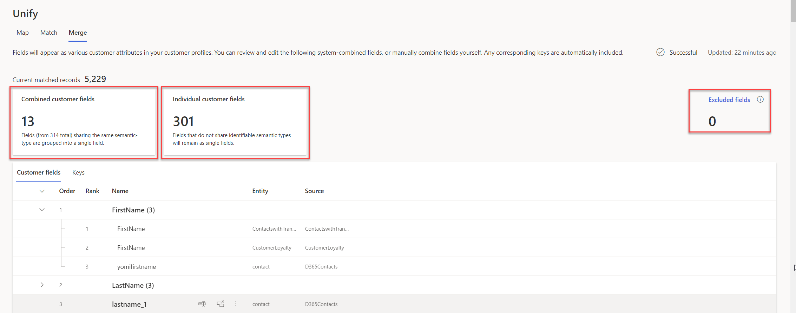

Note that attributes from all three data sources: ContactswithTransactions, CustomerLoyalty, and D365Contacts that are of the same type (e.g. First Name) have been ‘Merged’.

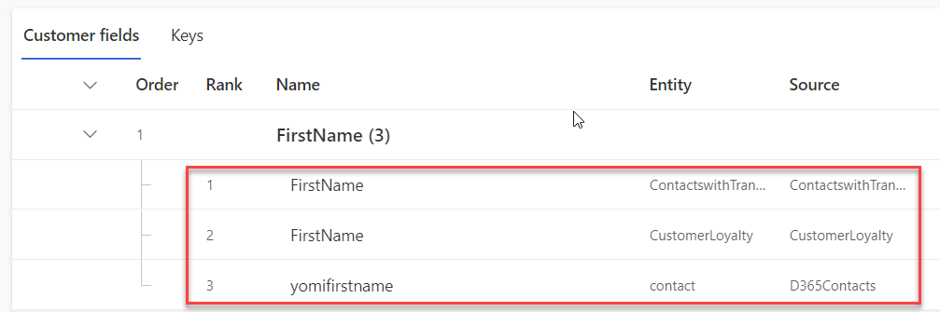

1. You can also view the importance rank, for example ContactswithTransaction is number 1. You can then do some actions such as, Separate field, Exclude, and also Move down to move the rank. In this case we will just leave it as it is as we defined in the Map process the sequence of the Data Source.

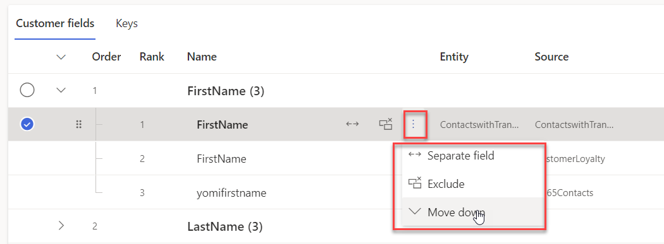

1. Note that the Primary Keys from the original sources cannot be merged. For example, we have a **ContactId** as the primary key from ContactswithTransactions and we also have **ContactId** within CustomerLoyalty. In fact, we are merging these records not on ContactId, but on FullName & Email.
2. On the **ContactId** for **loyCustomers** Entity, click the edit button 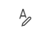 and rename the Display Name to **ContactIdLoyalty** to differentiate the item from the other IDs ingested and help avoid any confusion later.

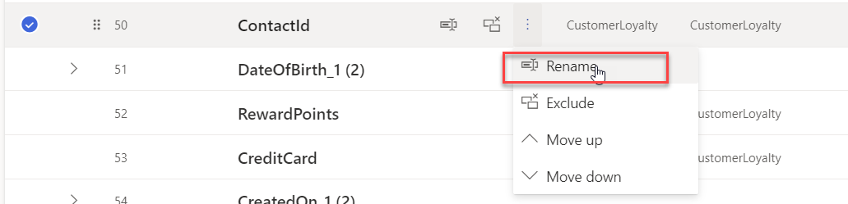

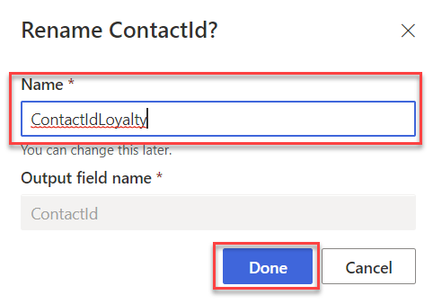

1. You can also combine D365 Contacts Image URl field and ContactsWithTransactions

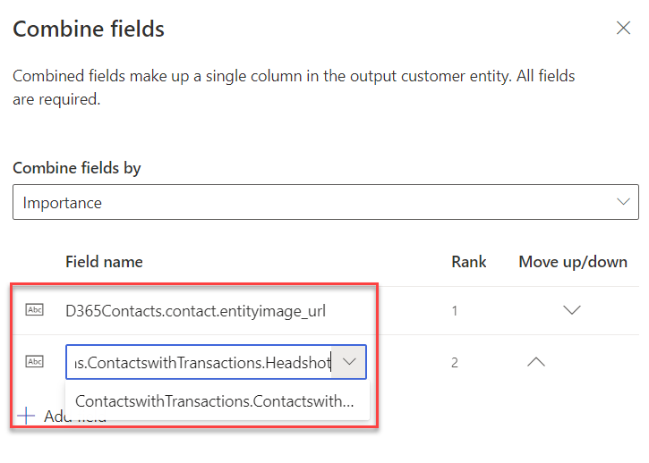

1. Click **Save** and **Run** to start the Merge Process.

Congratulations! You have successfully Ingested, Mapped, Matched and Merged data from multiple sources within Customer Insights to create a Unified Customer Profile that can be used to gain insights into your whole customer base!

## Exercise 2: Create Relationships and Measures

**Creating Relationships**

You will create different kinds of relationships to help join the different datasets together which help support other areas of Customer Insights which use these relationships to traverse the data sets.

**Measure Calculation**

You will calculate previously unobtainable key Business and Customer KPIs including  
Lifetime Spend, Club Points Balance, Average in Store and Average Online Purchase values.

**Relationships**

Before creating a measure, we need to understand the purchases made by a customer both online and instore. To do this we need to define the relationship between Purchases (made online and in store) and the Unified Customer Profile.

Relationships help you connect entities and generate a graph of your data. Relationships are used when entities share a common identifier (foreign key) that can be referenced from one entity to another. Connected entities enable you to define segments and measures based on multiple data sources.

**Measures**

Measures enables you to define all the key performance indicators (KPIs) that best reflect your specific business performance and health. Measures can either be customer-related measures such as Lifetime Value or business-health measures such as Monthly Active Users.   
  
Customer Insights provides an intuitive experience to build different types of measures, with a query-builder wizard that doesn’t require the user to manually code or validate the query.

Measures are calculated on a series of interactions that a company has with a customer, gathered from multiple data sources. Interactions are any customer touch points – these could include purchases, customer service cases, emails, phone calls, branch visits. In other scenarios interactions could also be data gathered from connected devices, withdrawals or deposits in banking, entry/exist of a premises or area etc.

#### Task 1 – Define the Relationship Between Unified Profiles and Online/E-Commerce Purchases

Define the relationship for **CustomerPurchasesEcom**

1. Under **Data** within the left-hand menu, click **Relationships** in the left-navigation menu

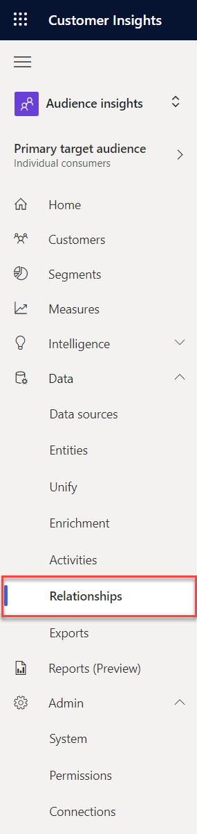

1. Click **New Relationship**

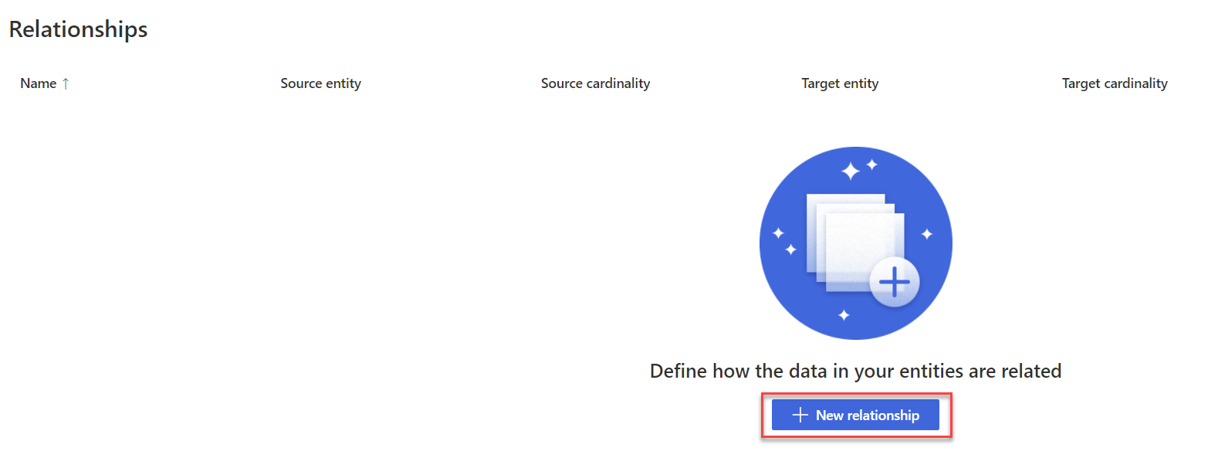

1. Name the relationship **CustomerPurchasesEcom**
2. In **Description** add **Online Purchases to Unified Customer Profile**
3. Set **Source** details entity to **eCommercePurchases: eCommerce** and **Cardinality** to **Many**
4. Set Target details entity to **Customer : CustomerInsights** and Cardinality to **One**
5. Set equivalent fields to **ContactId** for both the **Source** and **Target** fields.
6. Click **Save**

#### Task 2 – Define the Relationship between Unified Profiles and Store Purchases

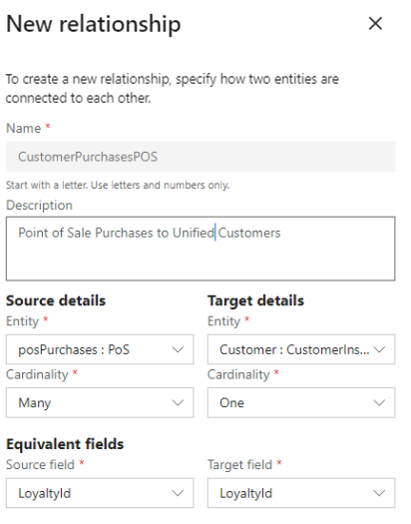

Define the relationship for **CustomerPurchasesPOS**

1. Under **Data** within the left-hand menu, click **Relationships** in the left-navigation menu
2. Click **New Relationship**
3. Name the relationship **CustomerPurchasesPOS**
4. In **Description** add **Point of Sale Purchases to Unified Customers**
5. Set **Source** details entity to **posPurchases: PoS** and **Cardinality** to **Many**
6. Set Target details entity to **Customer : CustomerInsights** and Cardinality to **One**
7. Set equivalent fields to **LoyaltyId** for both **Source field** and **Target field**
8. Click **Save**

You should now have the following relationships defined

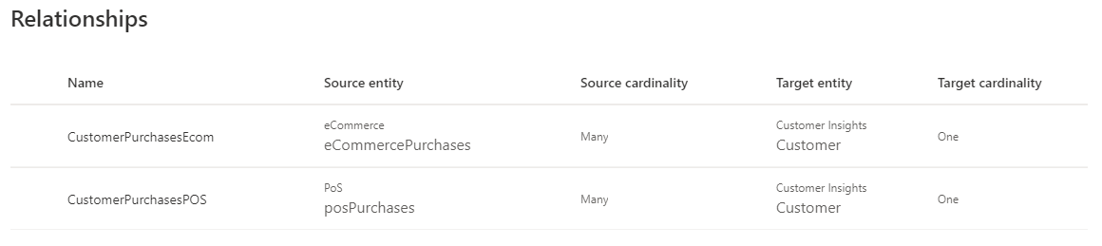

*To be added

## Exercise 3: Segments and Customer Cards

*To be added

## Exercise 4: Activities and Enrichment

*To be added

# Copyright

© 2021 Microsoft Corporation. All rights reserved.

By using this demo/lab, you agree to the following terms:

The technology/functionality described in this demo/lab is provided by Microsoft Corporation for purposes of obtaining your feedback and to provide you with a learning experience. You may only use the demo/lab to evaluate such technology features and functionality and provide feedback to Microsoft. You may not use it for any other purpose. You may not modify, copy, distribute, transmit, display, perform, reproduce, publish, license, create derivative works from, transfer, or sell this demo/lab or any portion thereof.

COPYING OR REPRODUCTION OF THE DEMO/LAB (OR ANY PORTION OF IT) TO ANY OTHER SERVER OR LOCATION FOR FURTHER REPRODUCTION OR REDISTRIBUTION IS EXPRESSLY PROHIBITED.

THIS DEMO/LAB PROVIDES CERTAIN SOFTWARE TECHNOLOGY/PRODUCT FEATURES AND FUNCTIONALITY, INCLUDING POTENTIAL NEW FEATURES AND CONCEPTS, IN A SIMULATED ENVIRONMENT WITHOUT COMPLEX SET-UP OR INSTALLATION FOR THE PURPOSE DESCRIBED ABOVE. THE TECHNOLOGY/CONCEPTS REPRESENTED IN THIS DEMO/LAB MAY NOT REPRESENT FULL FEATURE FUNCTIONALITY AND MAY NOT WORK THE WAY A FINAL VERSION MAY WORK. WE ALSO MAY NOT RELEASE A FINAL VERSION OF SUCH FEATURES OR CONCEPTS. YOUR EXPERIENCE WITH USING SUCH FEATURES AND FUNCTIONALITY IN A PHYSICAL ENVIRONMENT MAY ALSO BE DIFFERENT.

**FEEDBACK**. If you give feedback about the technology features, functionality and/or concepts described in this demo/lab to Microsoft, you give to Microsoft, without charge, the right to use, share and commercialize your feedback in any way and for any purpose. You also give to third parties, without charge, any patent rights needed for their products, technologies and services to use or interface with any specific parts of a Microsoft software or service that includes the feedback. You will not give feedback that is subject to a license that requires Microsoft to license its software or documentation to third parties because we include your feedback in them. These rights survive this agreement.

MICROSOFT CORPORATION HEREBY DISCLAIMS ALL WARRANTIES AND CONDITIONS WITH REGARD TO THE DEMO/LAB, INCLUDING ALL WARRANTIES AND CONDITIONS OF MERCHANTABILITY, WHETHER EXPRESS, IMPLIED OR STATUTORY, FITNESS FOR A PARTICULAR PURPOSE, TITLE AND NON-INFRINGEMENT. MICROSOFT DOES NOT MAKE ANY ASSURANCES OR REPRESENTATIONS WITH REGARD TO THE ACCURACY OF THE RESULTS, OUTPUT THAT DERIVES FROM USE OF DEMO/ LAB, OR SUITABILITY OF THE INFORMATION CONTAINED IN THE DEMO/LAB FOR ANY PURPOSE.

**DISCLAIMER**

This demo/lab contains only a portion of new features and enhancements in Microsoft Power Apps. Some of the features might change in future releases of the product. In this demo/lab, you will learn about some, but not all, new features.